2.1.5 Miscellaneous Topics

struct definition of a data type

not specify whether a given member has public, private, protected

union

no way to know what the data type is until runtime

static class data member

a global variable for its class

each class object(instance object) does not have its own exclusive copy

only one copy of a static data member and all class objects must share it

see the page 81-82

class Polynomial {

private:

static term termArray[MaxTerms];

static int free;

int Start, Finish;

};

main(){

term Polynomial::termArray[MaxTerms];

int Polynomial::free = 0;

}

2.1.6 ADTs and C++ classes

use the C++ class to define an ADT instead of the notation of ADT 1.1
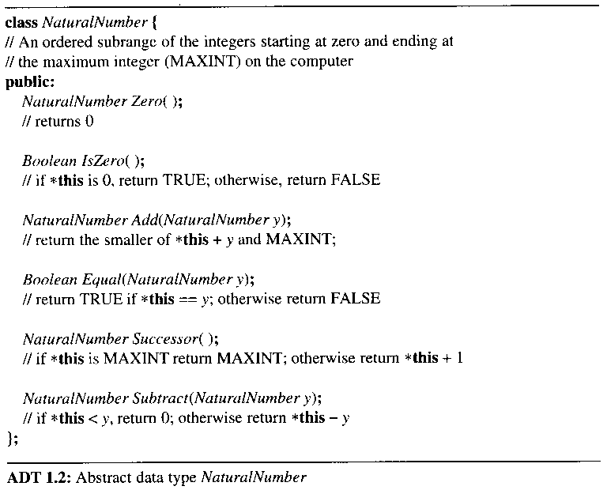

2.2 The Array as an Abstract Data Type

an array is a set of pairs, <index, value>, no two pairs in this set have the same index

we call the index a correspondence or a mapping

concerned with the operations that can be performed on an array

retrieve a value

store a value
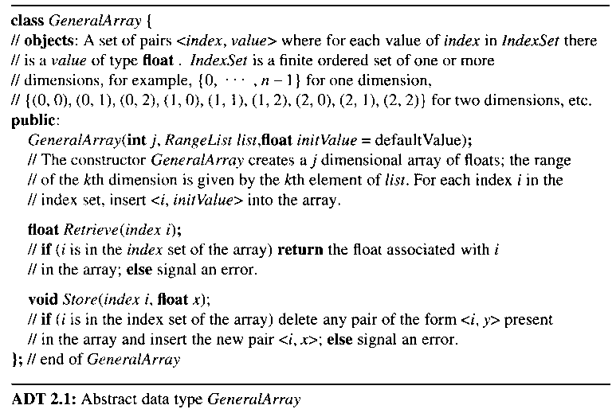

the advantage of ADT definition

the array is a more general structure than "a consecutive set of memory locations"

more general than the C++ array

more flexible about the composition of the index set

the C++ array

require the index set to be a set of consecutive integers starting at 0

do not check an array index

a C++ array example of floats

float exampIe[n];

accessed in two ways: example[i], or *(example+i)

- Figure 2.8 Lower and upper triangular matrices
- Figure 2.9 Tridiagonal matrix

2.3 The Polynomial Abstraction Data Type

arrays

data structures in their own right

use them to implement other abstract data types: the ordered, or linear list

data structure, list, (a₀, a₁, …, a_{n-1})

many operations on lists

find the length, n, of the list

read the list from left to right

retrieve the ith element

store a new value into the ith position

insert a new element at the position i

delete the element at position i

build an ADT for the representation and manipulation of symbolic polynomials

A(x) = 3x2 + 2x + 4

B(x) = x4 + 10x3 + 3x2 + 1

degree : the largest exponent of a polynomial

A(x) + B(x), A(x) * B(x)
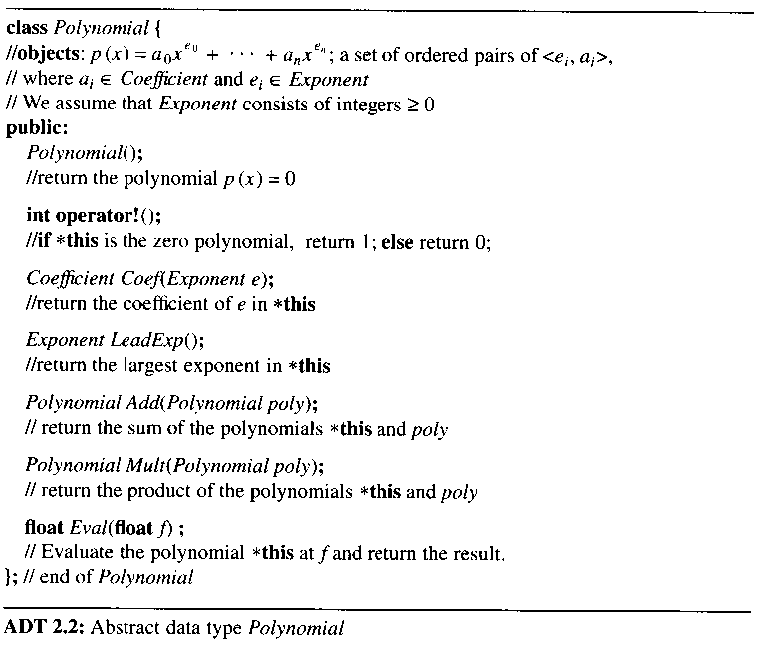

2.3.1 Polynomial Representation
* to arrange unique exponents in decreasing order

Representation 1: to define the private data members of Polynomial

private:

int degree;

float coef[MaxDegree + 1];

represent the polynomial A(x) as:

a.degree = n

a.coef[i] = a_{n-i}, 0 <= i <= n

a.coef[i] = the coefficient of xn-i

store the coefficients in order of decreasing exponents

Representation 2:

if a.degree « MaxDegree, then a.coef[0], ..., a.coef[N] are unused

define coef so that its size is a.degree + 1

private:

int degree;

float *coef;

adding the following constructor to Polynomial:

Polynomial::Polynomial(int d)

{

degree = d;

coef = new float [degree + 1];

}

Representation 3:

consider polynomials that have many zero terms, called sparse polynomials

x1000 + 1

b_{m}x^{em} + b_{m-1}x^{em-1} + . . . b₀x^{e0}

b₀ = a nonzero coefficient of A

ei decreasing e_{m} > e_{m-1}> ... > e₀ ≥ 0

represent polynomials in a single array called termArray

the singe array termArray is to be shared by all polynomials: a static class data member of Polynomial

class Polynomial; // forward declaration

class term {

friend Polynomial;

private:

float coef;

int exp;

}

define the private data members of polynomial as follows:

private:

//A, B에 의해 공유됨

static term termArray[MaxTerms];

static int free;

int Start, Finish

the required definitions of the static class members outside the class definition:

term Polynomial::termArray[MaxTerms];

int Polynomial::free = 0;

A(x) = 2x1000 + 1

B(x) = x4 + 10x3 + 3x2 +1
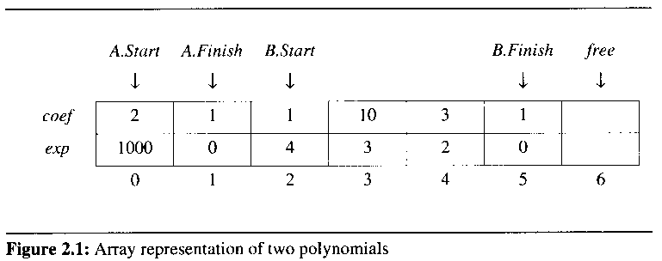

2.3.2 Polynomial Addition

C = A + B
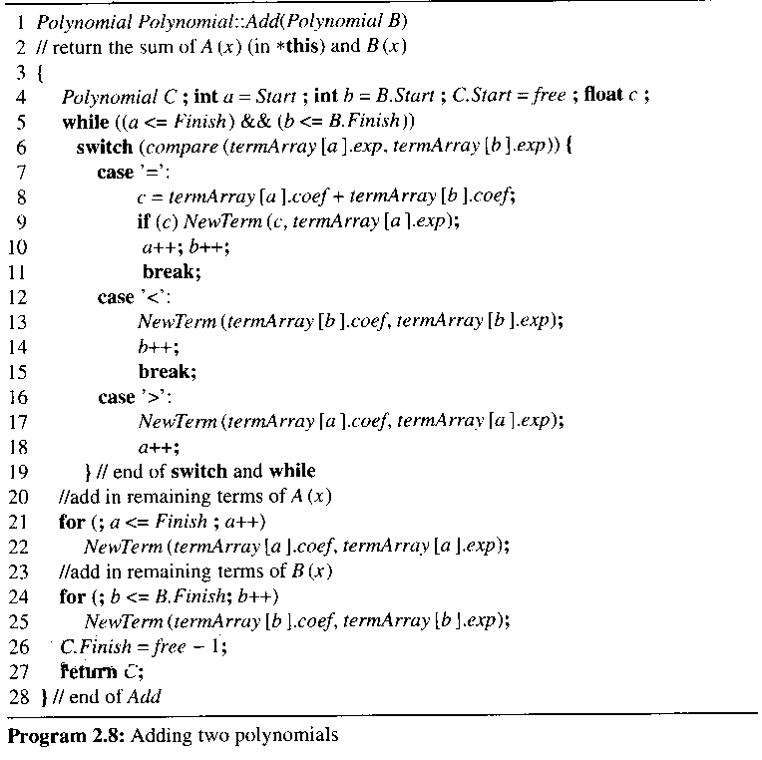

merging the terms of the two polynomials

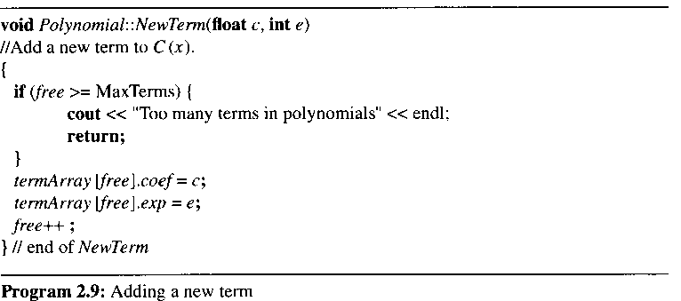

Analysis of Add:

let m and n be # of nonzero terms in A and B

# of iterations the while loop: m + n + 1

O(n + m) since non of the exponents are the same in A and B

2.3.3 Disadvantage of Representing Polynomials by Arrays

C = A + B

C를 새로 create

Free space가 필요

if there are some polynomials that are no longer needed

T1 = A + B

T2 = C + D

SUM = T1 + T2

T1, T2가 사용한 공간은 반환되어야 함

demand a complex compacting routine to make a large, contiguous free space

create dynamically the array by using new

메모리 관리 문제

linked list에서 중요한 문제임

the array is created dynamically by using new

2.4 SPARSE MATRICES

2.4.0 The class Matrix

Template<class T>

class Matrix {

public:

Matrix(int r=0, int c=0);

Matrix(const matrix<T>& m);

~Matrix() {delete [] element;}

Int Rows() const {return rows;}

Int Columns() const {return cols;}

T& operator() (int, int j) const;

. . .

private:

int rows, cols;

T *element;

};

2.4.1 Introduction

sparse matrices

have many zero entries
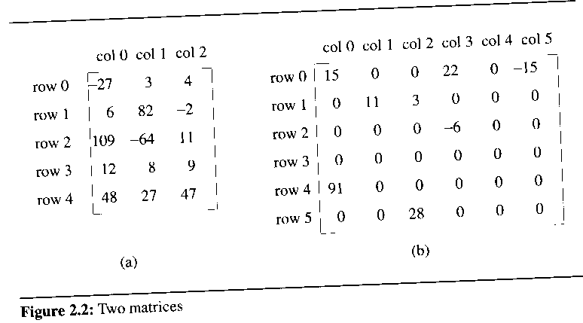

consider an alternate form of representation

should explicitly store only the nonzero elements

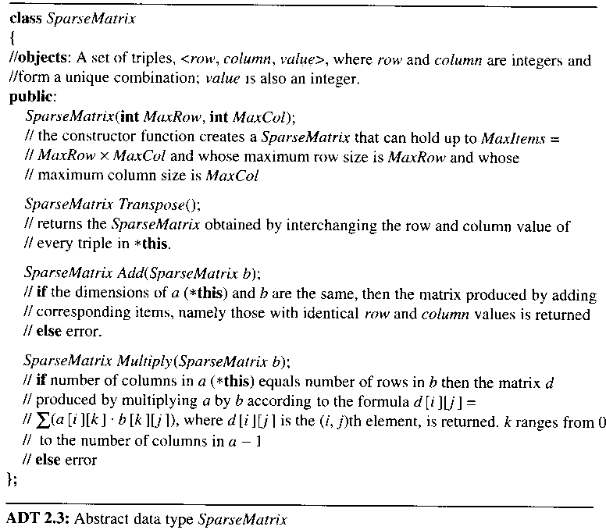

2.4.2 Sparse Matrix Representation

a set of triples 표현

represent a matrix by using the triple <row, col, value>

use an array of triples to represent a sparse matrix

row-major ordering

the column indices are in ascending order

class SparseMatrix

//triples <row, column, value> 표현

class MatrixTerm {

friend class SparseMatrix

private:

int row, col, value;

};

class SparseMatrix {

private:

int Rows, Cols, Terms;

// set 표현

MatrixTerm smArray[MaxTerms];

};

// Rows: # of rows, Cols : # of columns, Terms : # of nonzero terms
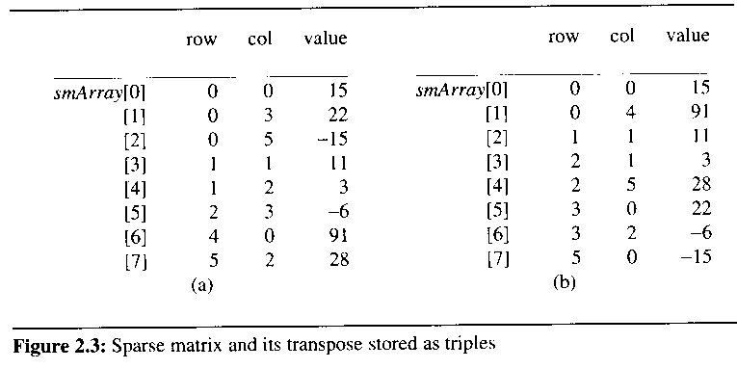

2.4.3 Transposing a Matrix

transpose a matrix

must interchange the rows and columns

for (each row i)

take element (i, j, value) and

store it in (j, i, value) of the transpose

the difficulty of transposing a matrix

not know where to put the element (j, i, value) until all other elements that precede it have been processed

(0, 0, 15) becomes (0, 0, 15) // no problem

(0, 3, 22) becomes (3, 0, 22) // where to put ??

for (all elements in column j)

place element (i, j, value) in position (j, i, value)

"find all elements in column 0 and store them in row 0"

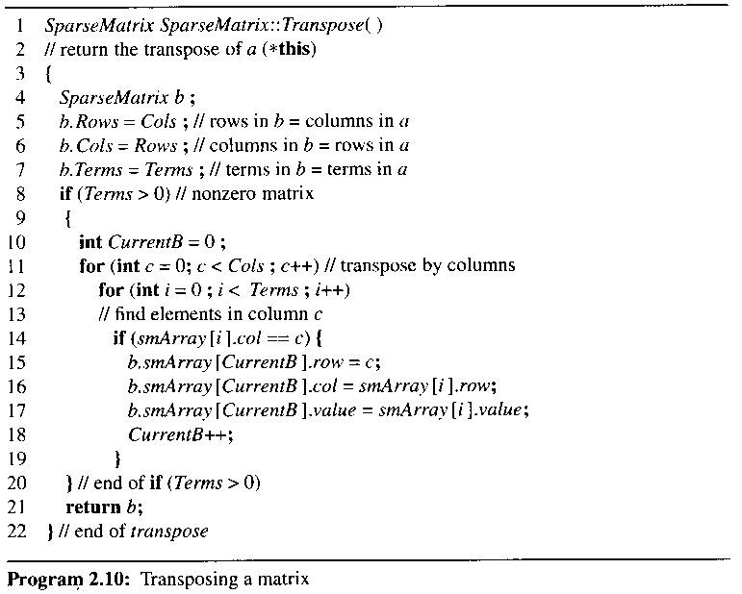

the variable CurrentB : the position in b where the next term in the transpose is to be inserted

Analysis of Transpose

O(terms * columns) // terms = rows * columns

becomes O(rows * columns2) where terms = columns * rows

the computing time of the transpose of a rows x columns matrix in time Ο(rows * columns)

for (int j = 0; j < cols, …)

for (int i = 0; I < rows, …)

B[j][I] = A[I][j]

transpose a matrix represented as a sequence of triples in time Ο(terms + columns)

called FastTranspose
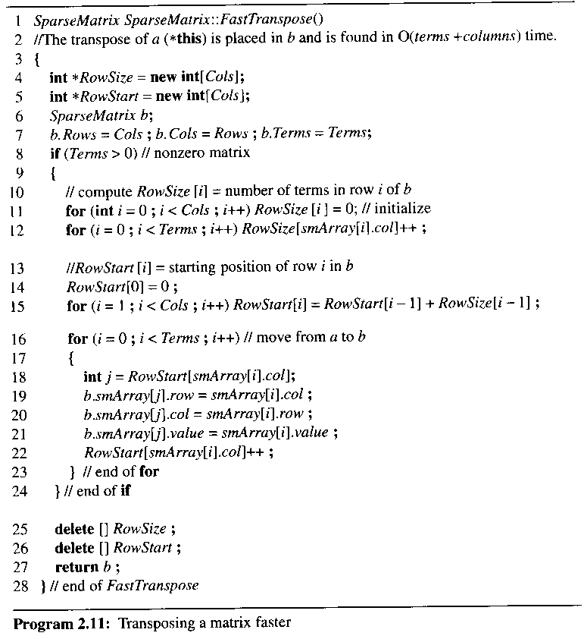

proceeds by first determining the number of elements in each column of A

obtain easily the starting point in b of each of its rows

the starting point, RowStart[i] of row i, of B

= RowStart[i-1] + RowSize[i-1]

// RowSize[i-1] = # of elements in row i-1 of B

after execution of the third for loop(line 15), the values of RowSize and RowStart:

[0] [1] [2] [3] [4] [5]

RowSize = 2 1 2 2 0 1

RowStart= 0 2 3 5 7 7

the computing time of FastTranspose

O(columns + terms)

four loops in fastTranspose, which are executed columns, terms, columns-1, and terms time respectively

2.4.4 Matrix Multiplication

Def) given A[m x n] and B[n x p], the product matrix Result[m x p] = A[m x n] * B[n x p]

result _{ij} = a_{ik} b_{kj}

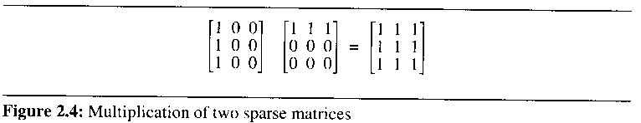

multiply two sparse matrices A and B represented as ordered lists

pick a row of A and find all elements in column j of B

have to scan all of B to find all the elements in column j

avoid this by first computing the transpose of B

put all column elements in consecutive order

do a merge operation
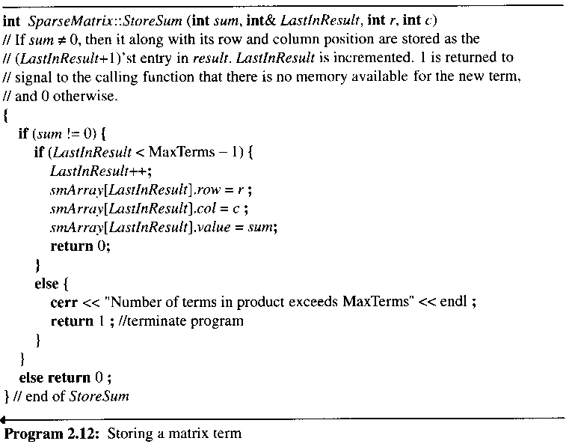

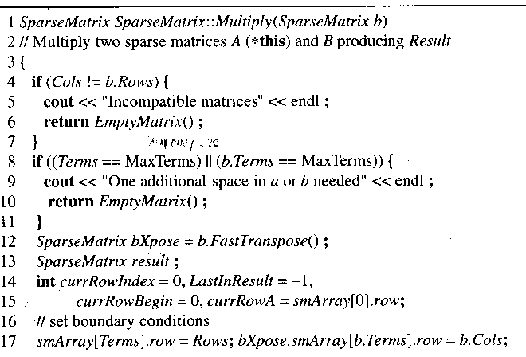
Program 2.13: Multiplying sparse matrix

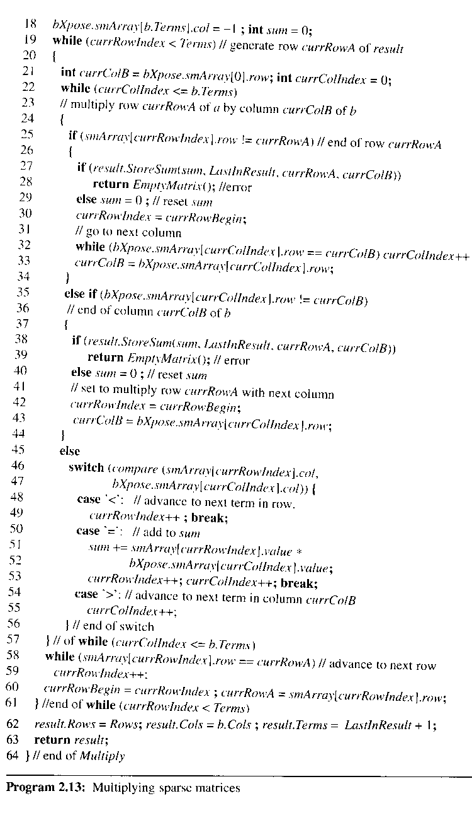

currRowA : the row of A that is currently being multiplied with the columns of B

currRowBegin: the position in a of the first element of row currRowA

currColB : the column of B that is currently being multiplied with the row currRowA of A

LastInResult: the position occupied by the last element of result

Analysis of Multiply

lines 4 to 18: require only O(B.Cols + B.Terms)

lines 19 to 61: executed at most A.rows

lines 22 to 57: executed at most B.Terms

tr : # of terms in row r of A

the value of currRowIndex can increase at most tr times before currRowIndex moves to the next row of A

reset currRowIndex to currRowBegin in line 30

resetting can occur at most B.cols times

the total maximum increment in currRowIndex : B.cols * tr

the maximum number of iterations of lines 22 to 57: B.cols + B.Terms + B.cols * tr

the iteration with row currRowA of A : O(B.cols * tr + B.Terms)

the overall time : O((B.cols * tr + B.Terms)) = O(B.Cols* A.Terms + A.Rows*B.Terms)

the classical multiplication algorithm

for (int i=0; i<A.Rows; i++)

for (int j=0; j<B.cols; j++)

{

sum = 0;

for (int k =0; k<A.cols; k++)

sum += a[i][k] * b[k][j];

c[i][j] = sum;

}

O(A.Rows * A.Cols * B.Cols)

in the worst case, A.Terms = A.Rows * A.Cols or B.Terms = A.Cols * B.Rows

Multiply becomes slower by a constant factor

2.5 Representation of Arrays

Develop a representation in which mapping A[i][j]..[l] onto a position in a one-dimensional C++ array

Can retrieve multidimensional arrays efficiently

row major ordering or column major ordering

A[4..5][2..4][1..2][3..4]

using row major order

A[4,2,1,3], A[4,2,1,4], A[4,2,2,3], ..

lexicographic order

A[4,2,1,3] is stored at position 0

A[4,2,1,4] is stored at position 1

C++ 언어가 row major order를 지원, 알고리즘은 column major order가 필요할 경우

sequential representation of A[u1]

A[0] = A1, A[i] = A1 + i
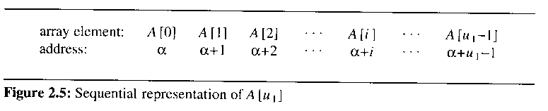

sequential representation of A[u1][u2]

A[0][0] = A1, A[i][0] = A1 + i * u2, A[i][j] = A1 + i*u2 + j
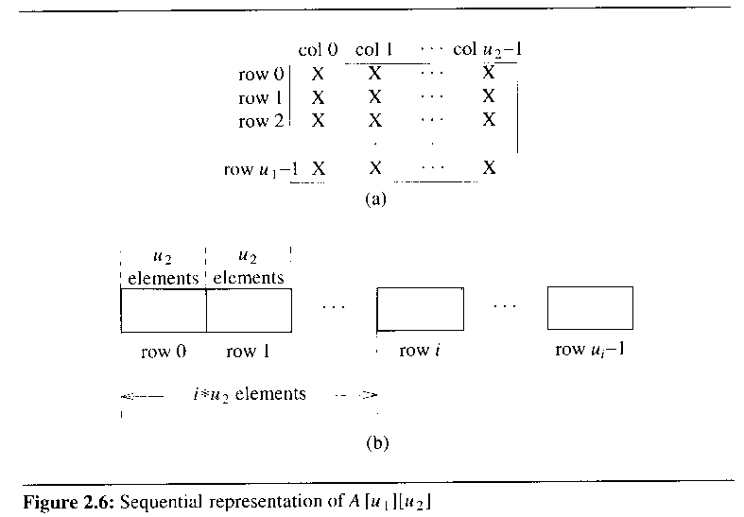

sequential representation of A[u1][u2][u3]

A[0][0][0] = A1, A[i][0][0] = A1 + i*u2*u3, A[i][j][0] = A1 + i*u2*u3 + j*u3

A[i][j][k] = A1 + i*u2*u3 + j*u3 + k

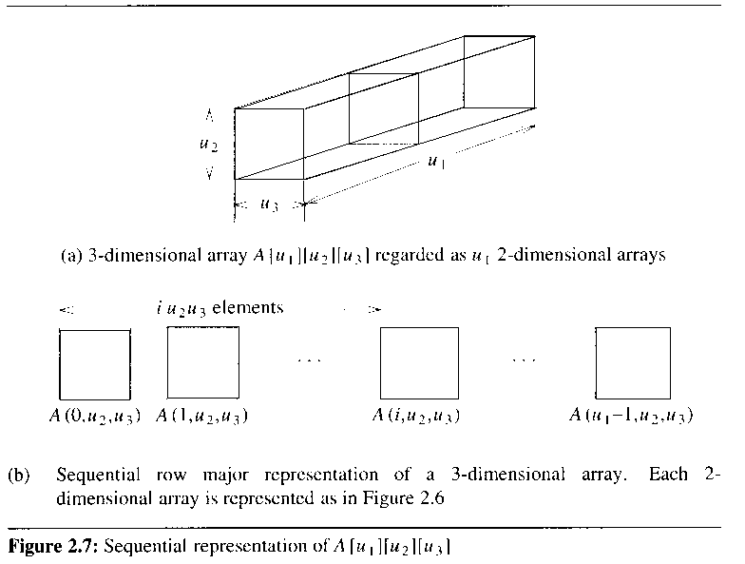

2.6 Representation of Special forms of Square Matrices

Diagonal

M(i,j) = 0 for i != j

Tridiagonal

M(i,j) = 0 for |i-j| > 1

Lower triangular

M(i,j) = 0 for i < j

Upper triangular

M(i,j) = 0 for i > j

Symmetric

M(i,j) = M(j,i) for all i and j

2.6.1 Diagonal Matrix

One way to represent an n x n diagonal matrix D with values of type T

T d[n][n]

T d[n]

Template<class T>

Class DiagonalMatrix {

Public:

DiagonalMatrix(int size =0)

{n = size; d = new T [n];}

~ DiagonalMatrix() {delete [] d;}

DiagonalMatrix<T>&

Store(const T& x, int I, int j):

T Retrieve(int I, int j) const;

Private:

Int n; //matrix dimension

T *d; //1D array for diagonal elements

};

본 강의 자료의 그림 및 알고리즘 발췌
저자 : HOROWITZ
타이틀 : FUNDAMENTALS OF DATA STRUCTURES IN C++ 2nd Edition (2006)
공저 : SAHNI, MEHTA
출판사 : Silicon Press

