Chapter 3 Stacks and Queues

3.1 Templates in C++

introduce the concept of templates

make classes and functions more reusable

3.1.1 Templates Functions

Program 1.3 1.6: sorts an array of integers using the selection sort method

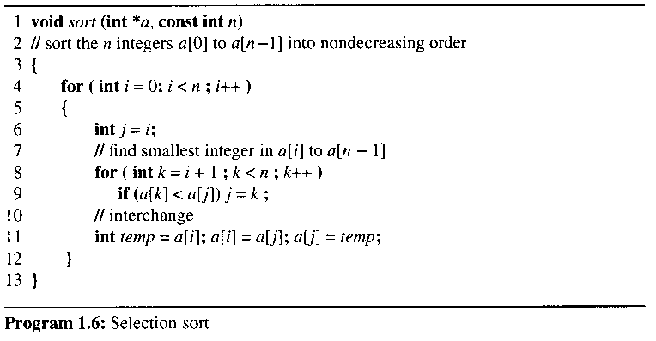

wish to use selection sort to sort an array of floating point numbers

achieve this by changing the program 1.6

templates

parameterized types

a variable that can be instantiated to any data type
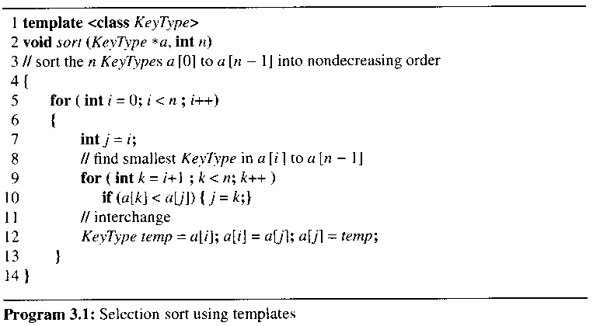

the copy constructor in line 12

distinguish an initialization from an assignment by the presence of a type specifier

KeyType temp = a[i];

the constructor function may be overloaded or default implementation

define temp to be a variable of type KeyType and initialize it to a[i]

invoked when an object is initialized with another object

3.1.2 Using Templates to Represent Container Classes

a container class

a class that represents a data structure that contains or stores a number of data objects

examples of a container class : array, bag

bag

have multiple occurrences of the same element

don't care about the position of an element

don't care which element is removed when a delete operation is performed
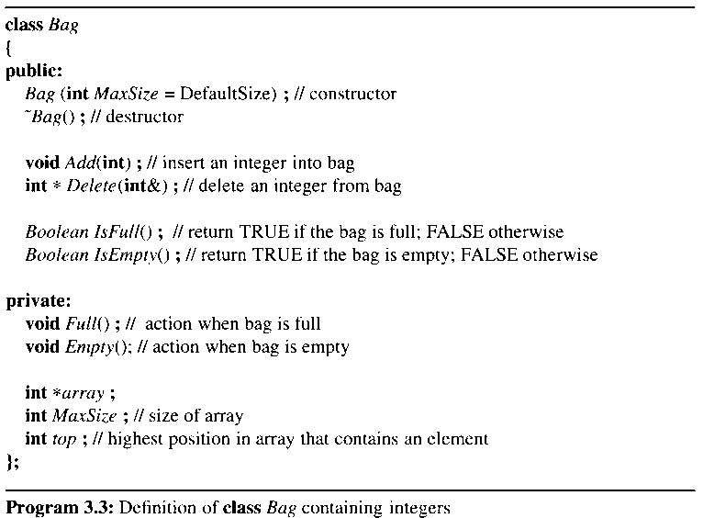

a data structure into which objects can be inserted and from which objects can be deleted

bag의 behaviors를 어떻게 구현하나?

the implementation of operations of Bag
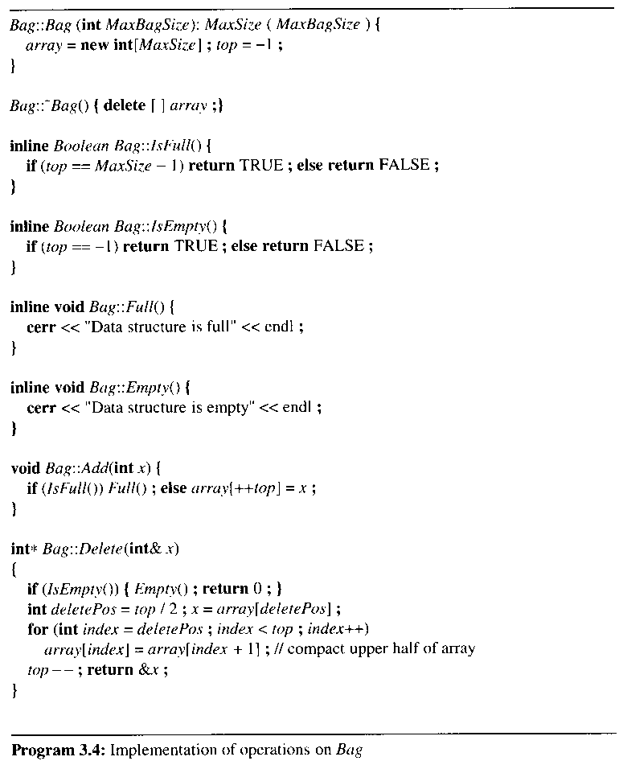

insert: store the element into the first available position in the array

delete: delete the element in the middle position of the array

midddle이 아닌 임의 장소의 객체를 삭제하는 것으로 구현 가능

member function Delete returns a pointer to an integer

suppose Delete returns the integer

if the bag is empty, then return (-1) to signal to the calling function that the bag is empty

how does the calling function know whether return (-1) or empty bag

the Delete ( ) function returns a pointer to an integer that is deleted from the bag

in the bag example, return a pointer to the appropriate array element

to implement Bag using templates to store objects of any data type

container classes are suitable for implementation using templates
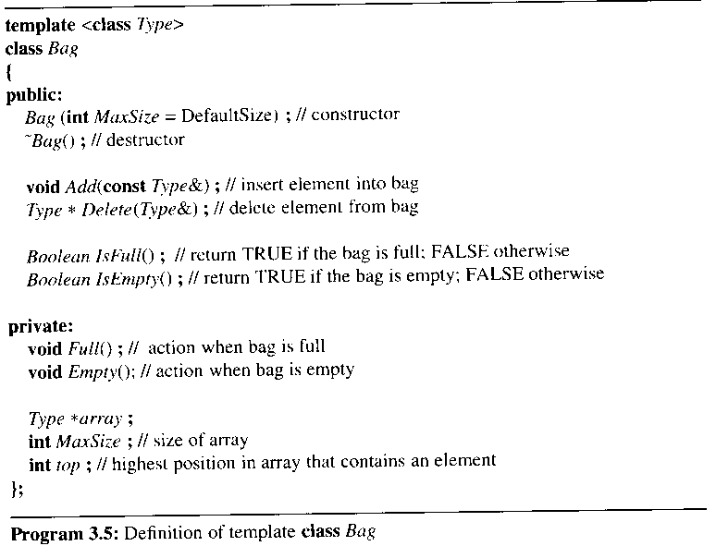

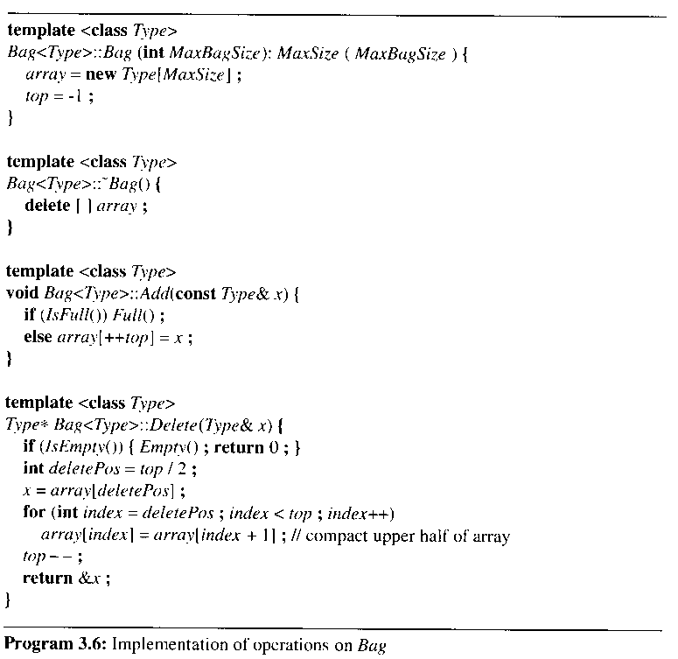

template <class Type>

Bag <int> a;

Bag <Rectangle> r;

3.2 The Stack Abstract Data Type

A = a₀, a₁, …, _{an-1} is an ordered list of n >= 0 elements

A stack is an ordered list in which insertions and deletions are made at one end

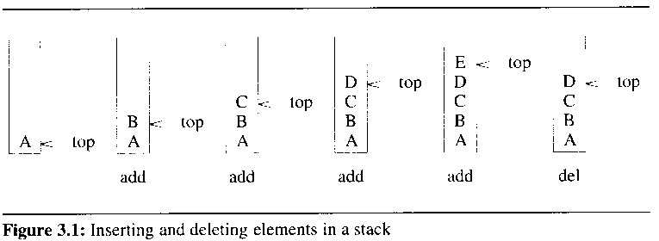

LIFO

An element of the stack describes an activation record or a stack frame

Local variables, previous frame pointer, return address

Example 3.1 [system stack]

place an activation record or a stack frame on top of the system stack

the activation record for the invoked function

contain a pointer to the previous stack frame and a return address

on top of the system stack : one function executed at any given time
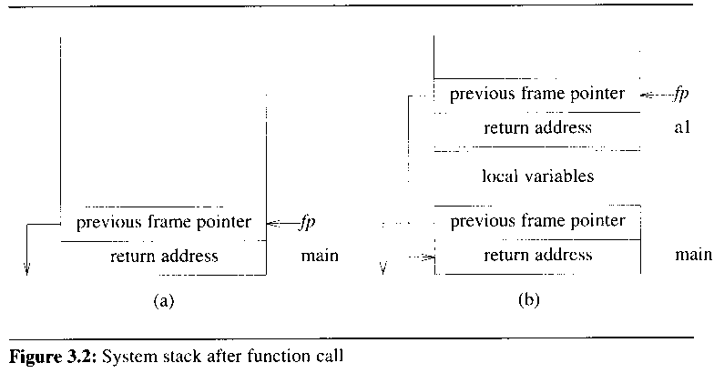

ADT specification of stack
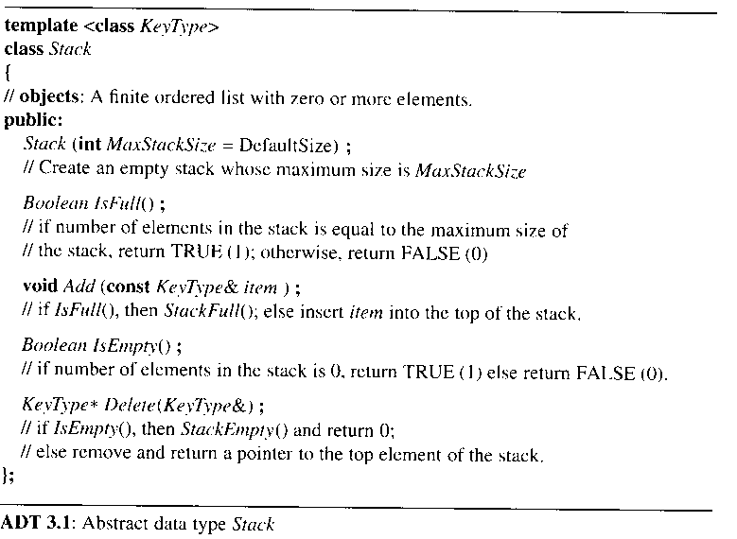

a way to implement ADT

to use a one-dimensional array, stack[MaxSize]

data member declarations and constructor definition of stack

private:

int top;

KeyType *stack;

int MaxSize;

template <class KeyType>

// a member initialization list

stack<KeyType>::stack (int MaxStackSize): MaxSize(MaxStackSize)

{

stack = new KeyType[MaxSize];

top = -1;

}

the member functions IsFull() and IsEmpty()

template <class KeyType>

inline Boolean stack<KeyType>::IsFull()

{

if (top == MaxSize -1 ) return TRUE;

else return FALSE;

}

template <class KeyType>

inline Boolean stack<KeyType>::IsEmpty()

{

if (top == -1) return TRUE;

else return FALSE;

}

the Add and Delete operations
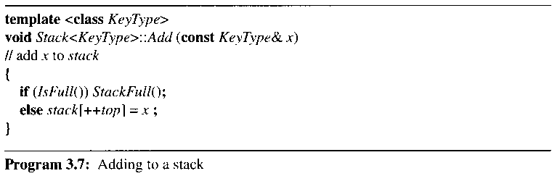

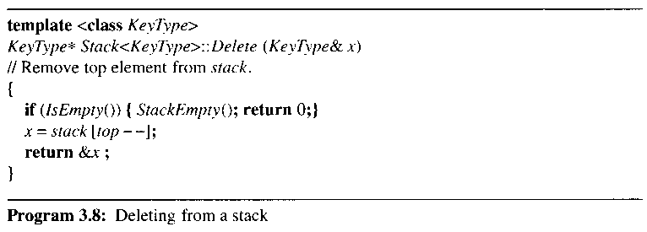

- ADT Bag, ADT Stack은 별 차이가 없다. 그리고 representation도 array 를 사용하고 top 변수를 쓰는 것은 같다. Bag와 Stack의 성질 차이는 어떻게 구현하나?
- ADT 타입이 bag와 stack의 semantics을 imply하는 것으로 생각함
- int, float 타입을 사용하는 것과 같음, boolean type에 대한 and, or 연산을 사용하지 곱셈 연산을 사용하지 않음
- ADT Set?
- Set, Bag, Stack, Queue 간의 class hierarchies?

3.3 The Queue Abstract Data Type

queue

an ordered list in which all insertions take place at one end and all deletions take place at the opposite end
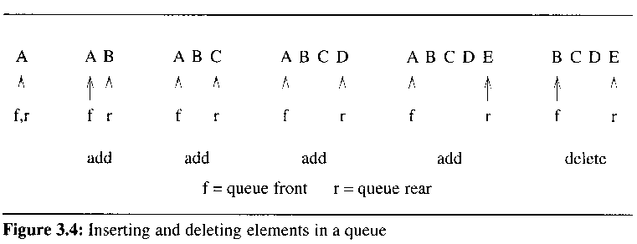

First-In-First-Out(FIFO) lists

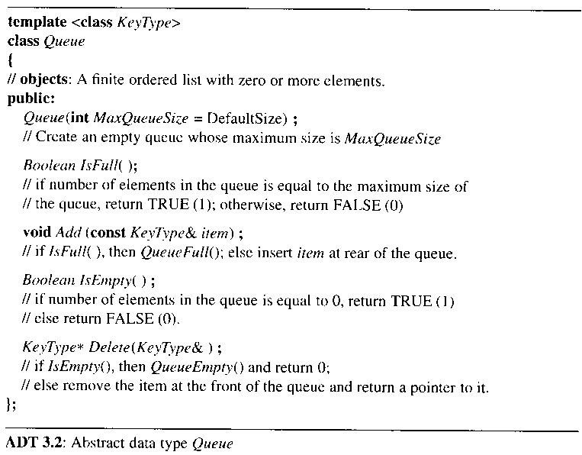

ADT에 FIFO를 직접적으로 표현하지 않음

FIFO는 Add( ), Delete( )의 주석으로 기술함

FIFO 구현은 Add, Delete 함수의 body에 표현

Add, Delete signature로 FIFO 시맨틱이 추상화됨

the representation of a queue

employ a one-dimensional array and two variables, front and rear

front < rear

data member declarations and constructor definition of Queue

private:

int front, rear;

KeyType *queue;

int MaxSize;

template <class KeyType>

Queue<KeyType>::Queue (int MaxQueueSize):MaxSize (MaxQueueSize)

{

queue = new KeyType[MaxSize];

front = rear = -1;

}

the member functions IsFull() and IsEmpty()

template <class KeyType>

inline Boolean Queue<KeyType>::IsFull()

{

if (rear ==MaxSize-1) return TRUE;

else return FALSE;

}

template <class KeyType>

inline Boolean Queue<KeyType>::IsEmpty()

{

if (front == rear) return TRUE;

else return FALSE;

}
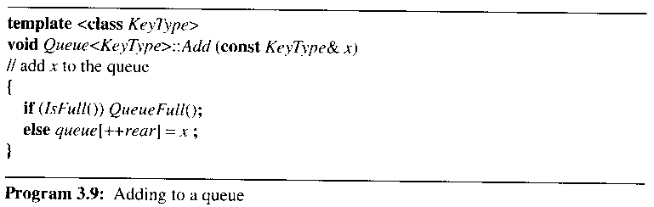

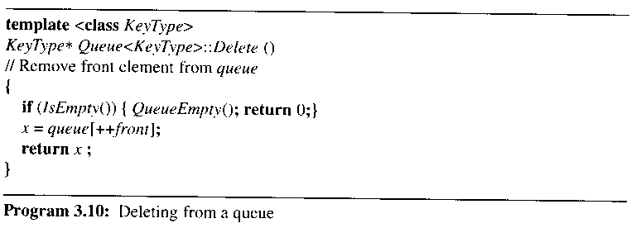

Example 3.2[Job Scheduling]
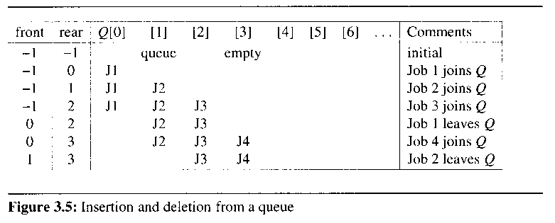

the queue gradually shifts to the right

the queue is full when rear = MaxSize -1

should move the entire queue to the left

FIG 3.6 Queue example

a more efficient queue representation : circular queue

circular queue는 새로운 ADT가 아니고 different representation임

if rear == MaxSize-1 then rear = 0

if front == rear then empty queue

if front == rear then queue is full

the queue contains Maxsize elements

permit a maximum of MaxSize-1 rather than MaxSize elements to be in the queue at any time

initial condition: front == rear == 1
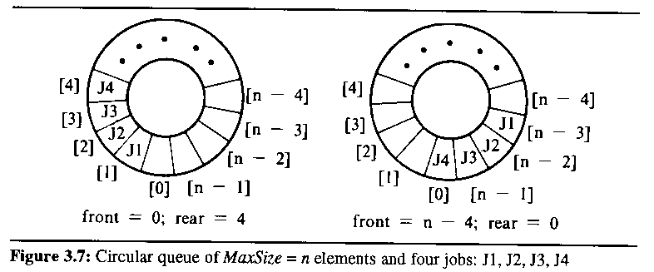

use the modulus operator to compute remainders: (rear+1) % MaxSize

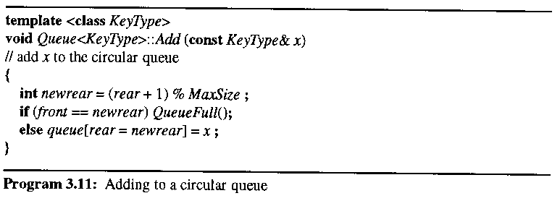

if (front == newrear) QueueFull();

a maximum of Maxsize – 1 rather than Maxsize
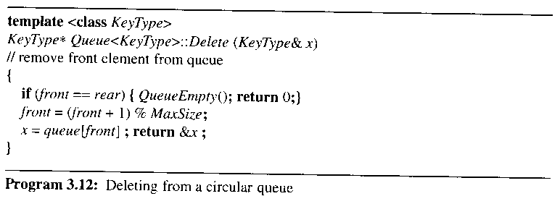

queue의 public interface는 변동이 없음

one way to use all MaxSize positions

to use a variable, LastOp, to record the last operation performed on the queue

add or delete operator

initialized to "delete"

set to "add" after each addition

set to "delete" following each deletion

if front == rear and LastOp == "add" then the queue is full

3.4 Subtyping and Inheritance in C++

inheritance

subtype relationships between ADTs

IS-A relationship

if B is-a A then B is more specialized

stack is a bag even if their implementations are changed

implement the IS-A relationship in C++ by using public inheritance
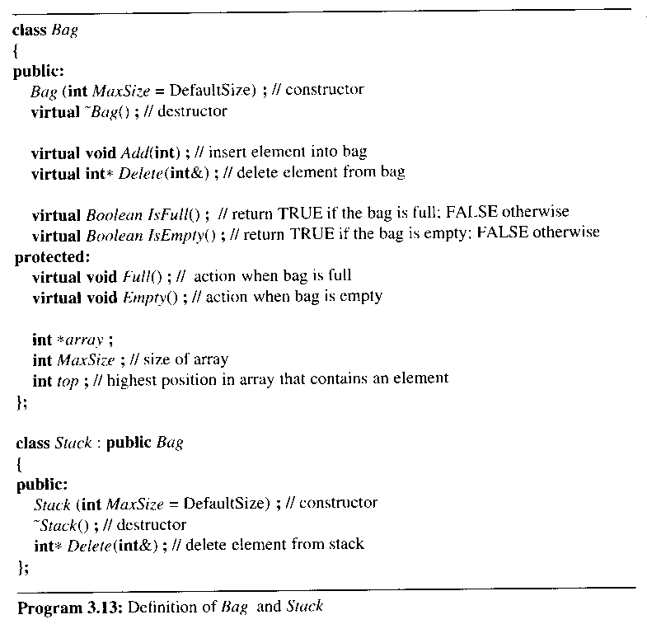

base class: Bag

derived class: Stack

inherit all the non-private members of the base class

inherited members have the same level of access in the derived class (under public inheritance)

possible to override the base class implementation
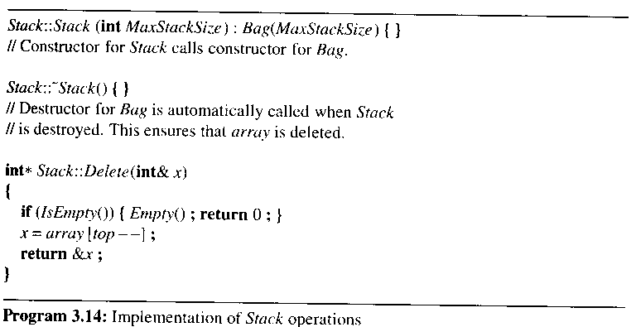

virtual member functions

class Bag

{public:

void Add(int);

…

};

dynamic binding?

Bag b(3); // use Bag constructor

Stack s(3); // use Stack constructor

b.Add(1); b.Add(2); b.Add(3);

// use Bag::Add

// Bag::Add calls functions Bag::IsFull and Bag::Full

s.Add(1); s.Add(2); s.Add(3);

// use Bag::Add, Stack::Add not defined

// Bag::Add calls Bag::IsFull and Bag::Full (not defined in Stack)

int x;

b.Delete(x); // use Bag::Delete

s.Delete(x); // use Stack::Delete

3.5 A Mazing Problem

represent the maze by a two-dimensional array, maze[i][j]

a blocked path : 1

can walk right on through : 0

start at maze[1][1], exit at maze[m][p]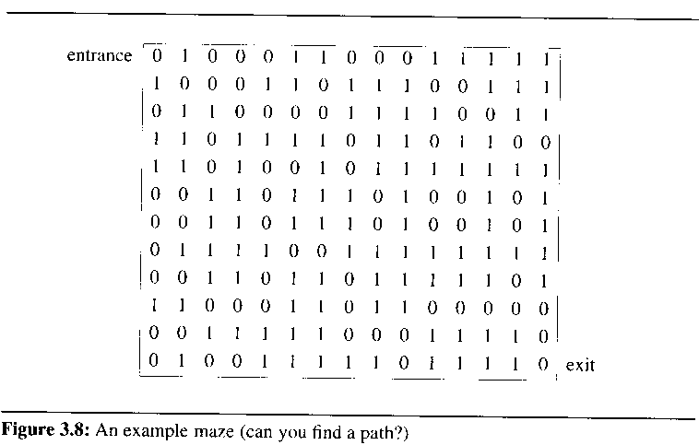

the possible moves the rat can make from a point [i][j] in the maze
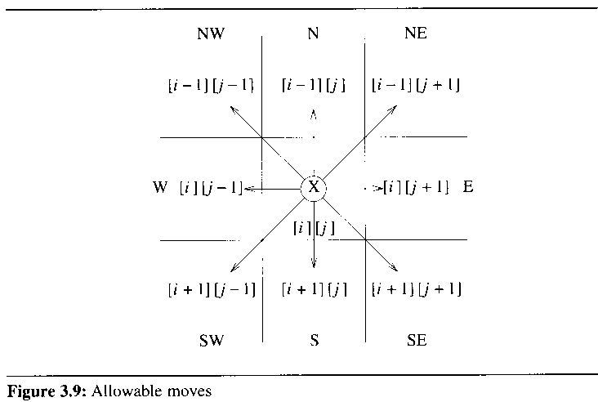

to avoid checking for border checking

use maze[m+2][p+2]

to predefine the possible directions to move in a table, move
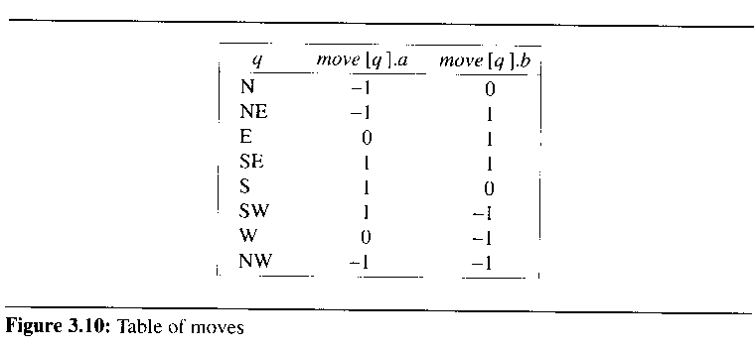

the data types to define the possible directions

struct offsets

{

int a, b;

}

enum directions [N, NE, E, SE, S, SW, W, NW};

offsets move[8];

to move the position [g][h] that is southwest from the position [i][j]

g = i + move[SW].a; h = j + move[SW].b;

find a path through a maze

pick one but save our current position and the direction of the last move in a list

if a false path, then return and try another direction

to prevent us from going down the same path twice

use another array, mark[m+2][p+2] which is initialized to zero

set mark[i][j] to 1 once we arrive at that position

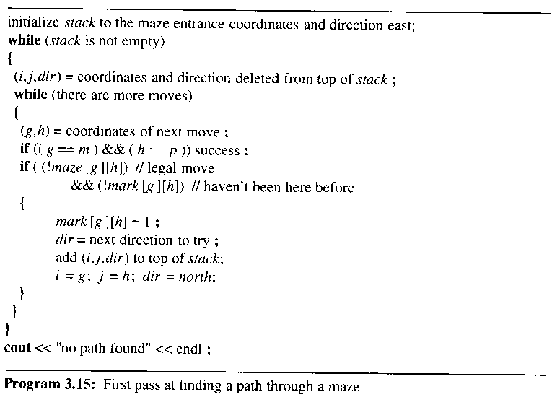

예제를 주었을 때 stack 변화를 보여주는 테스트
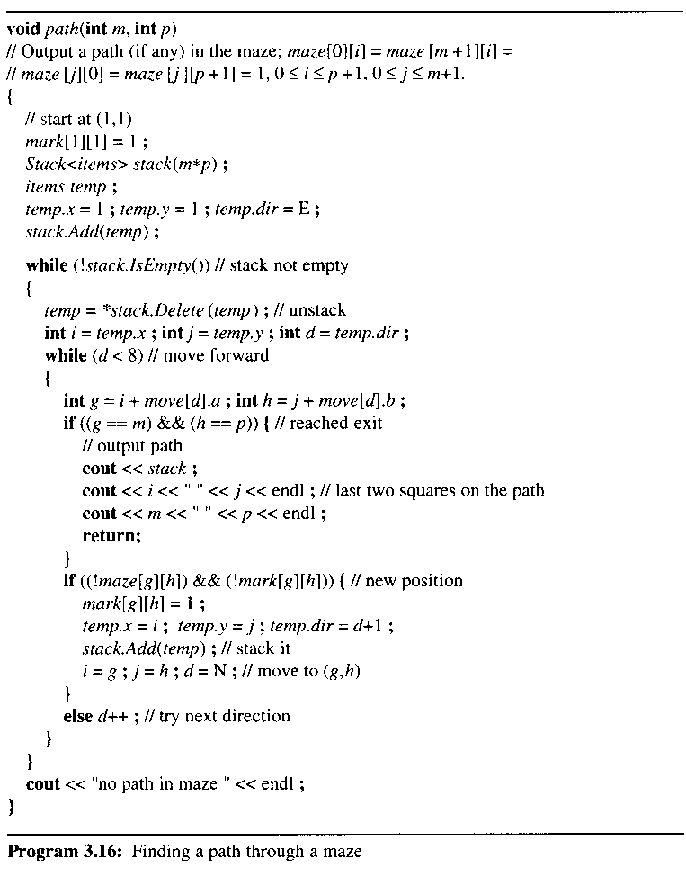

assume maze, mark, move to be global to path()

define stack to be a stack of items

struct items {

int x, y, dir;

};

overloaded operator << for both stack and items
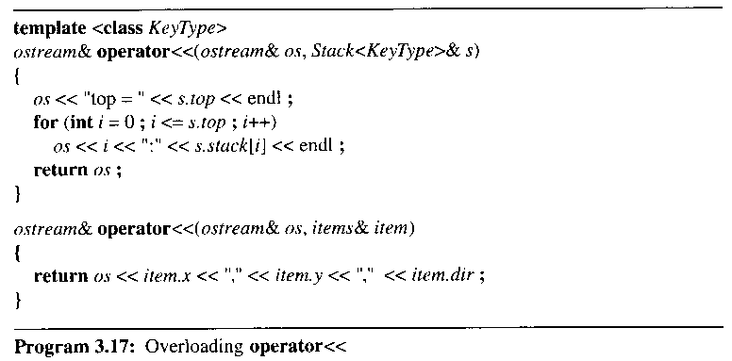

operator << accesses private data members of class stack

must be made a friend of stack

access to the private data members of stack through the use of the friend

difficult to make the computing time because of recursion

eight iterations of the inner while loop for each marked position

if # of zeros in maze = z, then at most z loops

the computing time O(mp)

at most mp elements can be placed into the stack

z is bounded by mp
본 강의 자료의 그림 및 알고리즘 발췌
저자 : HOROWITZ
타이틀 : FUNDAMENTALS OF DATA STRUCTURES IN C++ 2nd Edition (2006)
공저 : SAHNI, MEHTA
출판사 : Silicon Press

