3.6 Evaluation of Expressions

3.6.1 Expressions

X = A / B - C + D * E - A * C

to fix the order of evaluation, assign to each operator a priority

3.6.2 Postfix notation

infix notation

the operators come in-between the operands

tree에서 다시 공부하므로 철저히 학습 필요

convert the expression into a postfix notation

postfix form : call for each operator to appear after its operands

infix A*B / C -> postfix AB*C/

evaluate the postfix form by using the stack

the virtues of postfix notation that enable easy evaluation of expressions

infix: A / B - C + D * E - A * C

postfix: A B / C - D E * + A C * -

evaluating the postfix notation by using the stack
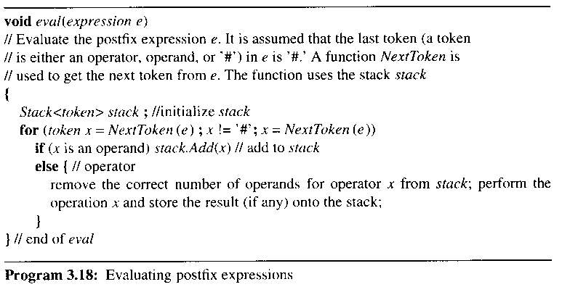

3.6.3 Infix to postfix

an algorithm for producing postfix from infix

1) fully parenthesize the expression

2) move all operators for replacing their corresponding right parentheses

3) delete all parentheses

infix: A / B - C + D * E - A * C

when fully parenthesized: ((( A / B ) - C ) + ( D * E )) - ( A * C ))

postfix: A B / C - D E * + A C * -

form the postfix by stacking

infix: A + B * C

next token stack output

------------- -------- --------

none empty none

A empty A

+ + A

B + AB

if * get placed on top of the stack or if the + gets taken off

priority of * is higher than +

stacking *

* +* AB

C +* ABC

if the input expression is empty, then output all remaining operators in the stack

ABC*+

infix: A * (B + C) * D

next token stack output

------------- ------- ----------

none empty none

A empty A

* * A

( *( A

B *( AB

+ *(+ AB

C *(+ ABC

unstack down to the corresponding left parenthesis

) * ABC+

* * ABC+*

D * ABC+*D

done empty ABC+*D*
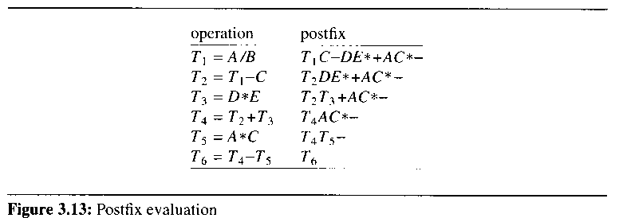

a priority-based scheme for stacking and unstacking operators

establish two priorities for operators : isp(in-stack priority) and icp(in-coming priority)
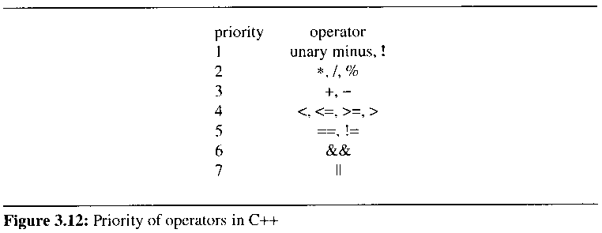

isp( '(' ) = 8, icp( '(' ) = 0, isp ( '#' ) = 8

stacking rule : operators are taken out of the stack as long as their in-stack priority is numerically less than or equal to the in-coming priority of the new operator
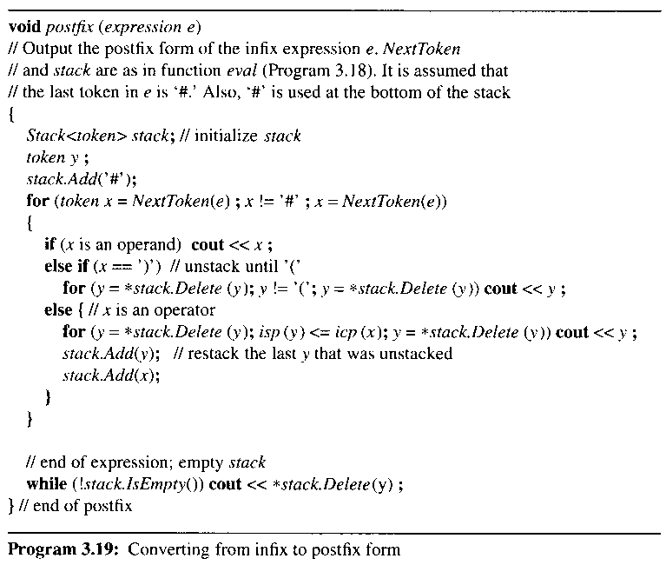

Chap 4 Linked Lists

4.1 Singly linked lists

a sequential mapping used for ordered lists

expensive insertion and deletion of arbitrary elements

require to move elements in the list either one location higher or lower

sequential representation for several ordered lists of varying sizes

waste an unused space

compute the size of the dynamically allocated list

linked representation

pointer or link

the elements no longer occur in sequential order
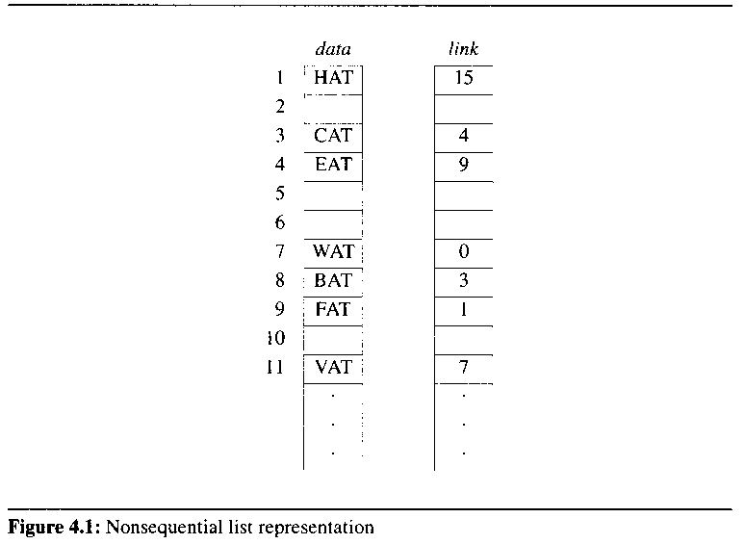

to draw linked lists as an ordered sequence of nodes with links being represented by arrows
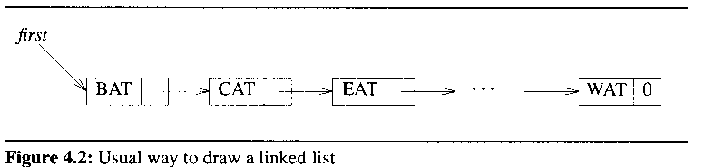

why it is easier to make arbitrary insertions and deletions using a linked lists rather than a sequential list
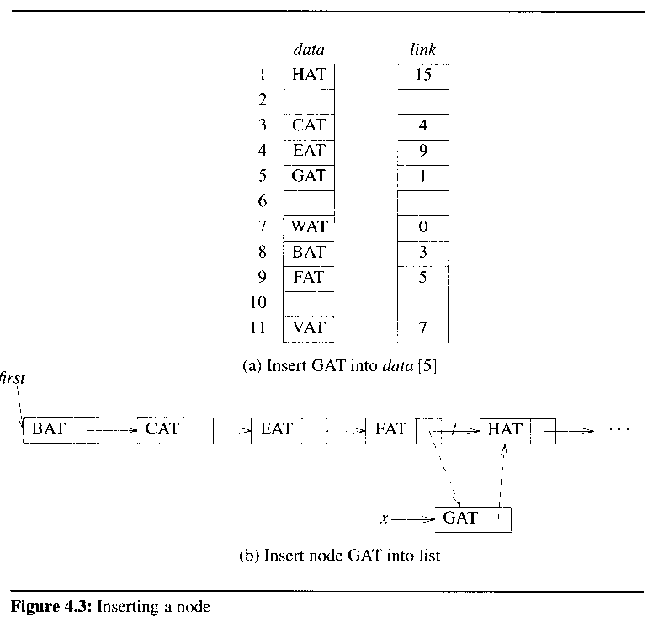

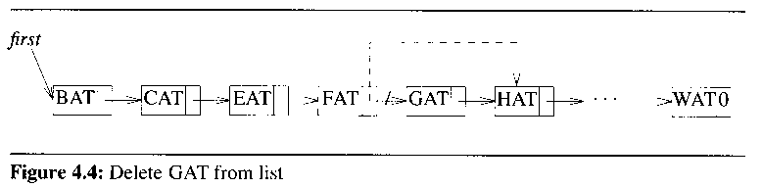

4.2 Representing chains in C++

a set of objects를 정의하는 클래스?

object를 정의하는 class

list를 정의하는 class

4.2.1 Defining a list node in C++

class ThreeLetterNode {

private:

char data[3];

ThreeLetterNode *link;

};

Example 4.1: class definitions for link lists

class nodeb {

private:

int data;

nodeb *link;

};

class nodea {

private:

int data1;

char data2;

float data3;

nodea *linka;

nodeb *linkb;

};
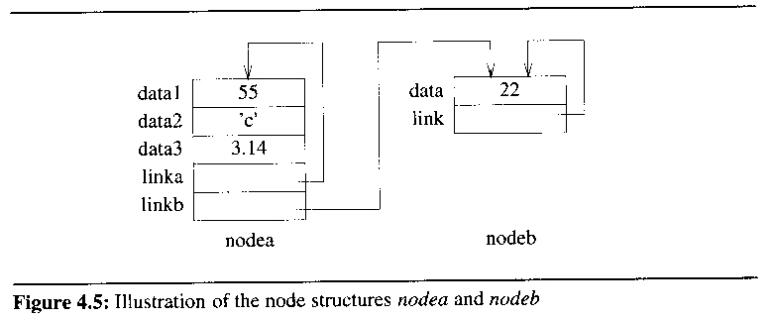

4.2.2 Designing a list in C++

how to represent a single node in C++
Design attempt 1

ThreeLetterNode *first; // considered to be a global variable

reference the data members of the node pointed to by first

first→data, first→link

first→data[0], first→data[1]
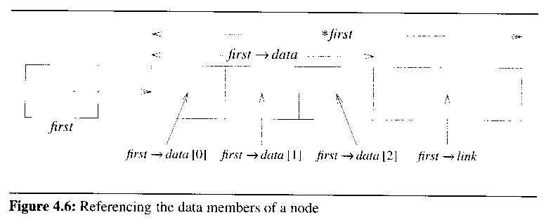

compile-time errors because private data members cannot be accessed from outside the class

Example 4.1: private representation

Design attempt2

make the data members public

do the trick

violate data encapsulation

to define public member functions GetLink(), SetLink(), GetData(), SetData()

used to indirectly access the data members

not a good solution because any function in the program can access data members of ThreeLetterNode

a good solution : only grant the functions that perform list manipulation operations: insert a node, delete a node

no other functions should have access to data members of ThreeLetterNode

Design attempt 3

need to tackle data structure design problem

to implement a singly linked list

should contain a class corresponding to the entire list data structure

this class should support member functions that perform list manipulation operations

ThreeLetterList has-a ThreeLetterNode

다항식을 정의하는 class와 유사함

class term {

friend Polynomial;

private:

float coef;

int exp;

};

class Polynomial {

...

private:

static term termArray[MaxTerms];

};

Definition: A has-a B iff A contains B or B is a part of A
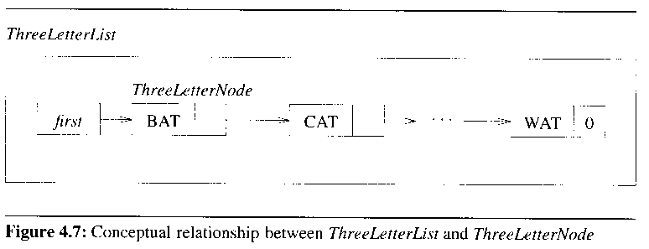

Objects of ThreeLetterNode are declared as data members of ThreeLetterList

ThreeLetterList physically contains many objects of class ThreeLetterNode

# of nodes in a linked list is not a constant

be impossible to know in advance the number of ThreeLetterNodes in ThreeLetterList
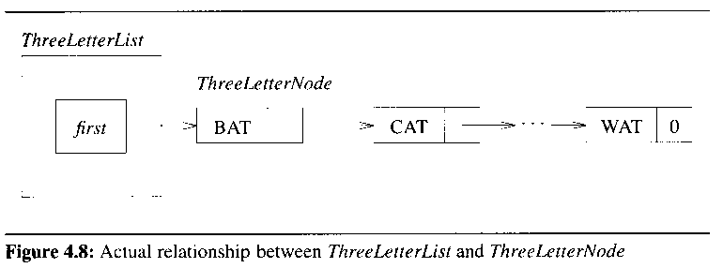

contain only the access pointer

ThreeLetterNode objects are not physically contained inside ThreeLetterList

a solution of dilemma of how to define class ThreeLetterNode so that only list manipulation operations have access to its data members

achieved by declaring ThreeLetterList to be a friend of ThreeLetterNode

friend: member functions of ThreeLetterNode and ThreeLetterList can access the private data members of ThreeLetterNode

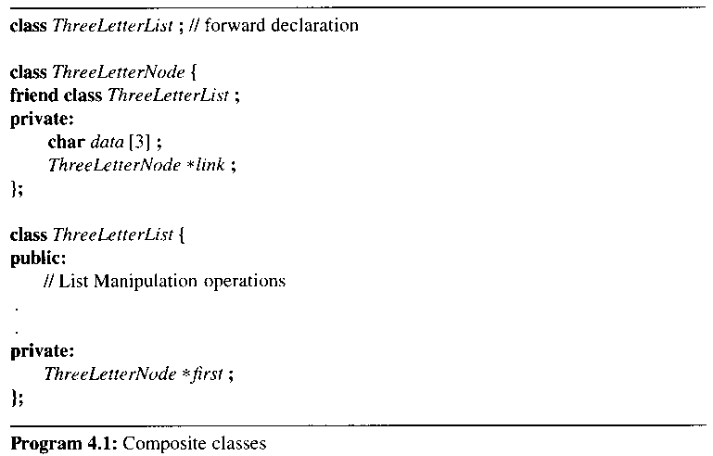

4.2.3 Pointer manipulations in C++

create nodes of a type by using the C++ command new

ThreeLetterNode* y, z;

y = new nodea;

z = new nodeb;

*y, *z denote the nodes of type NodeA and NodeB

delete y; delete z;

allow pointer variables to be assigned the null pointer constant 0

permit addition of integers to pointer variables (have no logical meaning)

y++

compare two pointer variables of the same type

y == z, y != z, y !=0

Figure 4.9 Effect of Pointer assignments

4.2.4 List manipulation operations

must declare list manipulation operations as member function of the list class

class ListNode {

private:

int data;

ListNode *link;

};

class xxList {

public:

// list manipulation operations

private:

ListNode *first;

}

assume the access pointer first to be a private data member of List

Example 4.2

create a linked list with two nodes of type ListNode
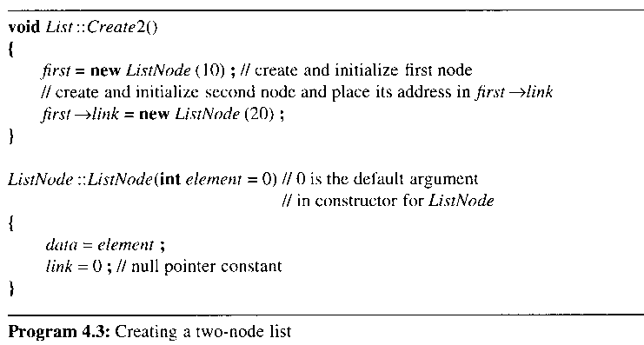

Example 4.3, 4.4

Program 4.4, Chain::Insert50( )

Program 4.5 Chain::Delete( )

see the page 184: problem3,4

4.3 A Reusable Linked List Class

4.3.1 Implementing linked lists with templates

a linked list is a container class

a good candidate for implementation with templates
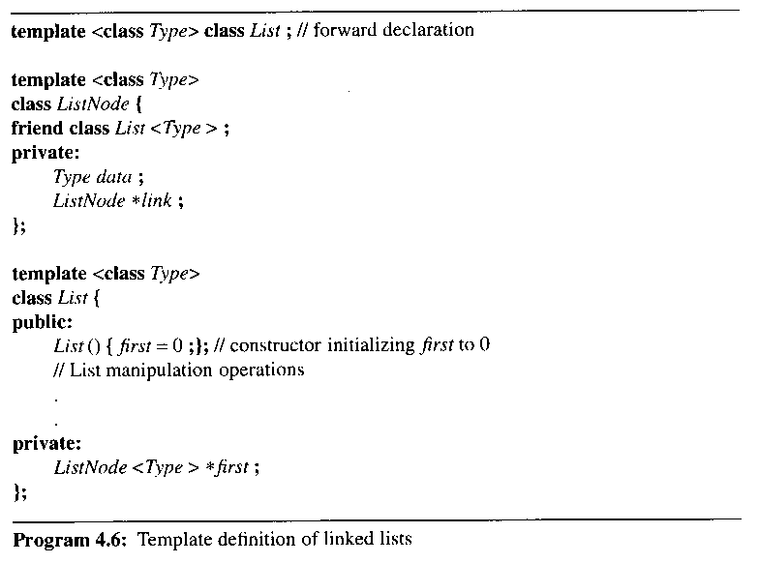

List<Type> : a friend of ListNode<Type>

declare first to be a pointer to object ListNode<Type>

define an empty linked list of integers intlist

List <int> intlist;

임의의 클래스가 있을 때 template으로 정의할 수 있을 것-이것이 프로그래밍 능력임

4.3.2 Linked lists iterators(Chain Iterators)

motivate the need for iterators of a container class

1) print all integers in class C

2) obtain the max, min, mean, median of all integers in C

3) obtain the sum, product, or sum of squares of all integers in C

4) obtain all integers in C that satisfy some property P

5) obtain the integer x from C such that, for some function f, f(x) is max

an iterator

an object that is used to traverse all the elements of a container class one by one

while loop를 object로 인식하는 개념이 필요

OLE/COM, ODBC, JDBC이해에 매우 중요

the pseudo-code for traversing all elements of the container class

initialization step;

for each item in C

{

current = current item of C;

body;

}

postprocessing step;

적색 라인: depend on the container class

all operations of the type have to be implemented as member functions of the particular container class

to find the maximum of all elements in the container class

for (int I=0;I<n;I++)

{

current = a[I];

x = max(current,x);

}

int x = -MAXINT;

for (ListNode<int> *ptr = first; ptr != 0; ptr = ptr->link)

{

current = ptr->data;

x = max(current, x);

}

return x;

The max element have to be implemented as member functions of the container class as these operations access private data members of the container class. There are some drawbacks to this approach:

1) all operations will be member functions of List<Type> if the container class is the template list class

all of its operations should be independent of the type of object to which T is instantiated

if the body: computing the sum of all objects, then do not make sense when the objects are of type Rectangles

2) It is not feasible for the class designer to predict all the operations required by a particular user of the class

He would be forced user to add that operation to the container class

list<Type>에 모든 operations을 미리 만들어 놓을 수 없음

3) have to learn how to traverse the container class, even if the added member functions are allowed

suggest that the iterative operations be moved outside the definition of List<Type>

the iterative operations

no modify the contents of the linked list

need to access private data members of List<Type> and ListNode<Type>

define a third class ListIterator<Type>

handle the details of the linked list traversal

retrieve elements stored in the list
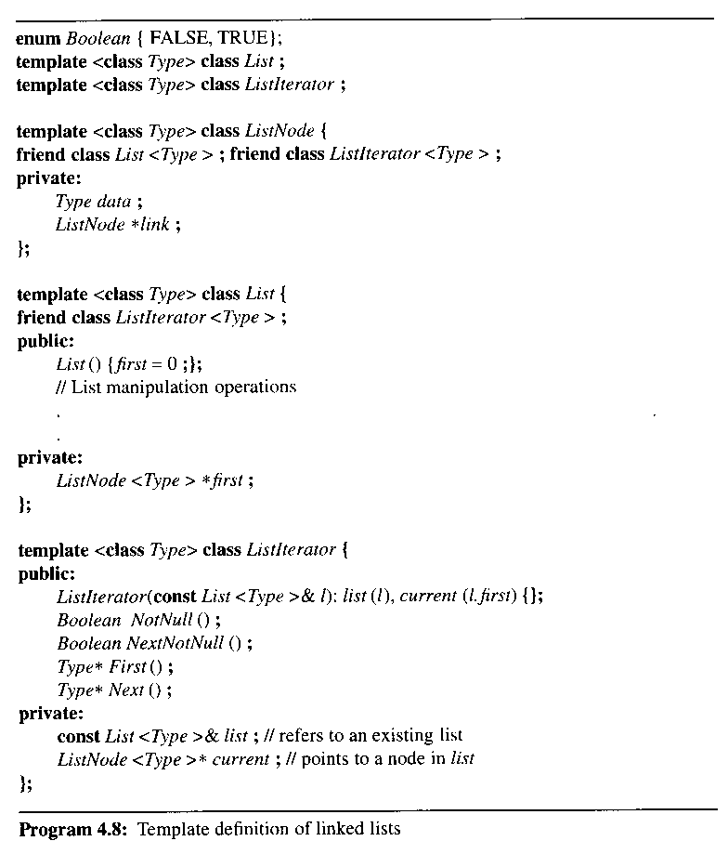

Program 4.9 List iterator functions
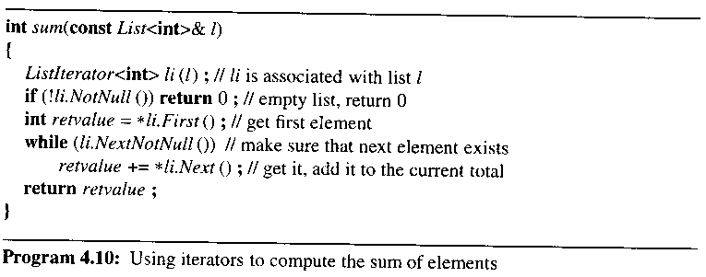

do not require access to the private data members of List<Type> or ListNode<Type>

examine why it is better to define a third class ListIterator than to augment the List class with the private variable current and the four public member functions

page 194: exercise 4.

Not possible for multiple iterators to be defined on the same list if the iterator operations are implemented as member functions of List<Type>

Let x₁,x₂,…,x_{n} be the elements of a chain. To compute the sum(i=1, n-5) (x_{i} * x_{i+5})

4.3.3 Linked list operations

choose which operations to include in reusable classes

important to provide enough operations so that the class can be used in many applications

important not to include too many operations

constructors

a destructor

an assignment operator (operator =)

the test-for-equality operator (operator ==)

operators to input and output a class object (operator >>, operator <<)

see how to implement the destructor for linked lists

useful operations in reusable classes

insertions to, deletions from, and other manipulations of the linked list

attach an element to the end of a list
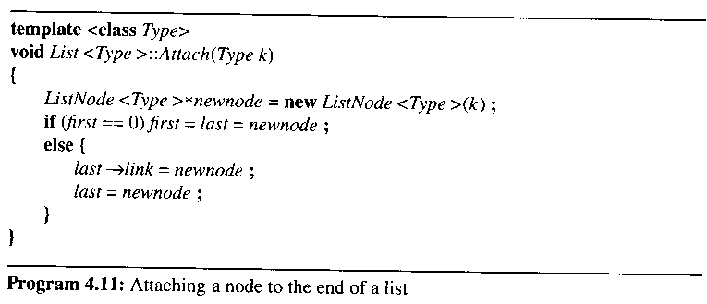

invert a chain "in place"

make use of three pointers

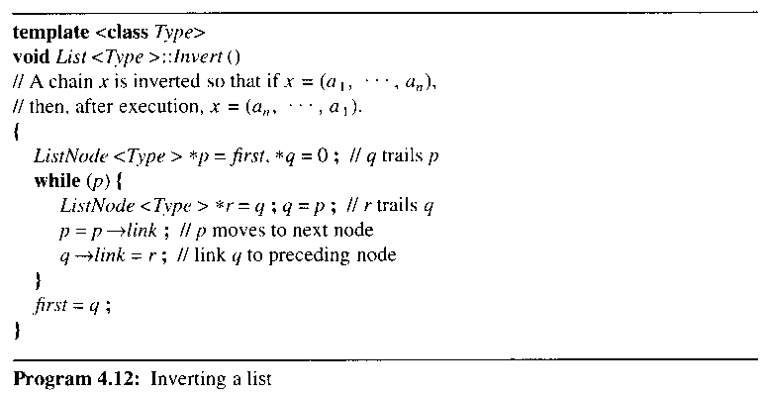

concatenate two chain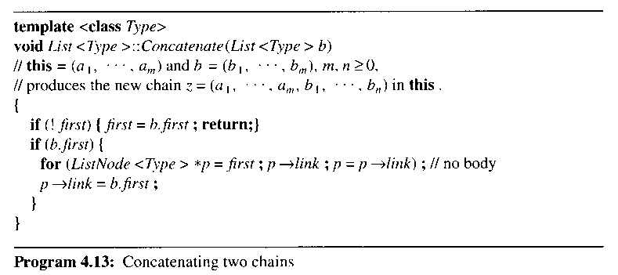

주요 학습 내용:

invert( ), concatenate( ) 알고리즘을 기억하는 것이 중요한 것이 아니고 두개의 list가 있을 때 merge하는 메카니즘을 이해하고 이를 활용할 수 있는 능력을 가지는 것이 중요함

-> merge with two sorted lists

4.3.4 Reusing a class

illustrate how class Polynomial can be implemented by reusing the linked list class: section 4.6

some scenarios where one should not attempt to reuse a class

1) less efficient than directly implementing class

if efficiency is of paramount importance, then implement another class

use linked lists to implement stacks and queues: section 4.6 uses chains to implement stacks and queues

data structure가 다른 응용에서도 재사용되지만 매우 중요한 데이터 구조라면, 가장 효율적인 구조로 직접 구현하는 것이 바람직

2) if the operations required by the applications are complex and specialized, do not reuse an existing classes

implement equivalence classes directly

section 4.8 implements equivalence classes directly
본 강의 자료의 그림 및 알고리즘 발췌
저자 : HOROWITZ
타이틀 : FUNDAMENTALS OF DATA STRUCTURES IN C++ 2nd Edition (2006)
공저 : SAHNI, MEHTA
출판사 : Silicon Press

