4.4 Circular lists

Why circular list?

check whether a pointer current points to the last node

check for (current->link == first)

circular list를 사용하는 이유: Figure 4.13(section 4.7.3: circular list representation of polynomials)

ensure that the link of the last node points to the first node of the list

insert a new node at the front of the list

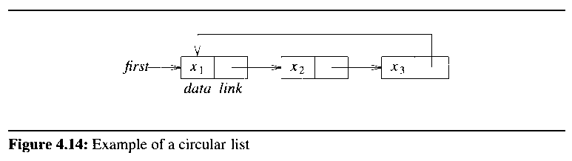

have to change the link data member of the node x3

have to move down the entire length of a list until the last node

point to the last node rather than to the first

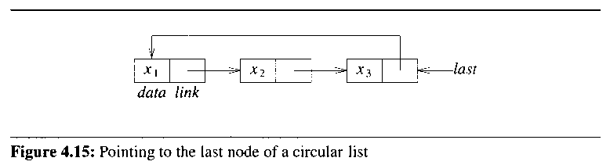

to insert x at the front
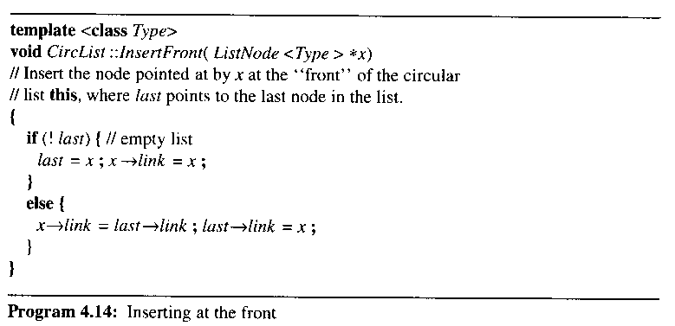

assume the existence of class CircList

contain the private data member last that points to the last node
- list, circular list, doubly linked list에 대한 ADT, class, representation를 정의할 수 있을 것

have to handle the empty list as a special case

introduce a dummy head node into each circular list
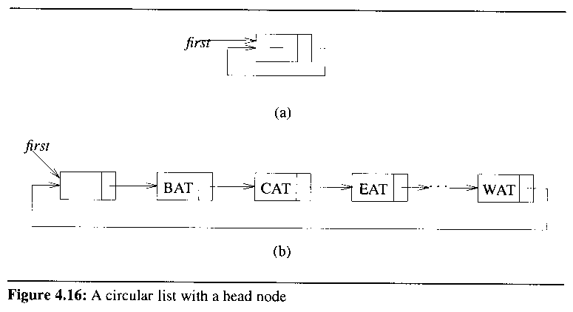

4.5 Available Space Lists

the destructors for chains and circular lists take time linear

Let av be a static class member of CircularList<T>

available space list or av list = the chain of deleted nodes

Program 4.15: GetNode( )

Program 4.16: RetNode( )

Program 4.17: ~CircularList( ) – assume Figure 4.15 for last

Figure 4.17: the link changes involved in deleting a circular list

4.6 Linked stacks and queues

when several stacks and queues coexist

no efficient way to represent them sequentially
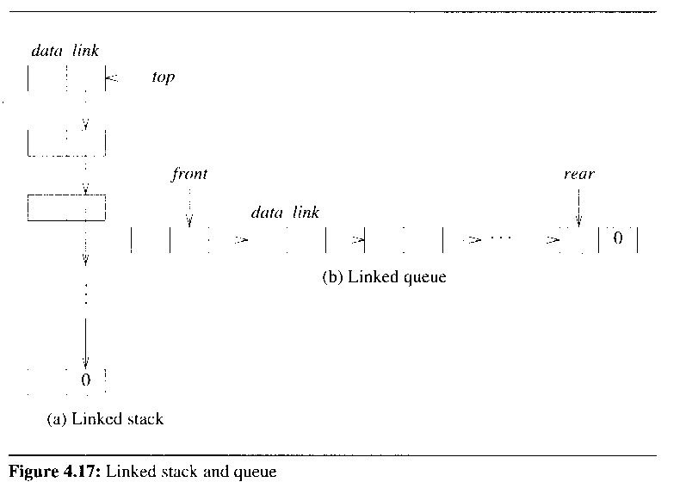

a collection of m stacks and n queues

no need to shift stacks or queues around to make space

a collection of m stacks and n queues is obtained:

Stack *stack = new Stack[m];

Queue *queue = new Queue[n];
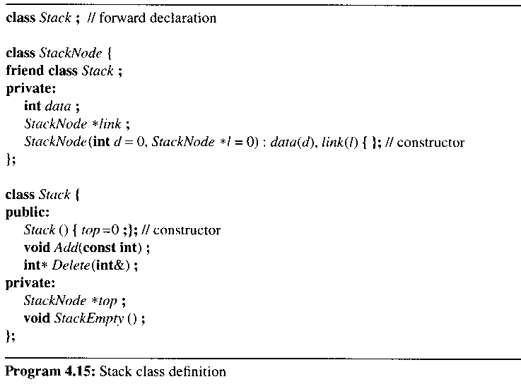

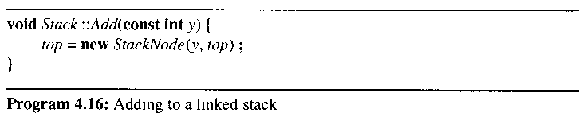

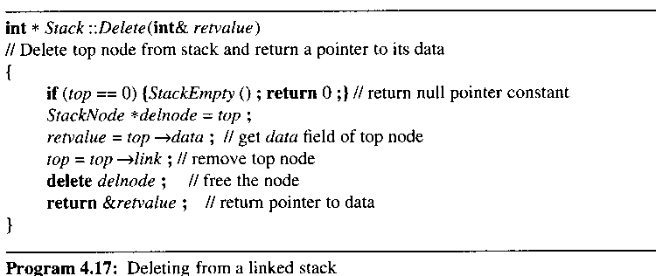

- the n-stack, m-queue problem
  - the solution of linked stacks and queues
    - both computationally and conceptually simple
- stack과 queue는 다른 응용에서 재사용되는 중요한 데이타 구조임
  - implement stacks and queues directly to make them as efficient as possible

4.7 Polynomials(구판 내용이 더 논리적)

illustrate how class Polynomial can be implemented by using the linked list class

4.7.1 Polynomial representation

be able to represent any number of different polynomials within main memory

define a Polynomial class to implement polynomials

polynomials is-implemented-by List

declare List as a data member of the Polynomial

make the linked list object poly a data member of Polynomial

use struct rather than class to define Term

make the data members of Term public

any function that has access to a Term object also has access to its data members

do not violate data encapsulation for Polynomial
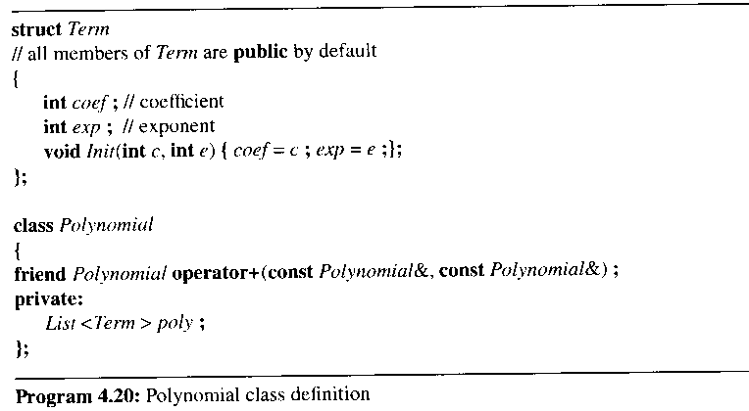

4.7.2 Adding polynomials

to add two polynimials a and b, use the list iterators Aiter and Biter

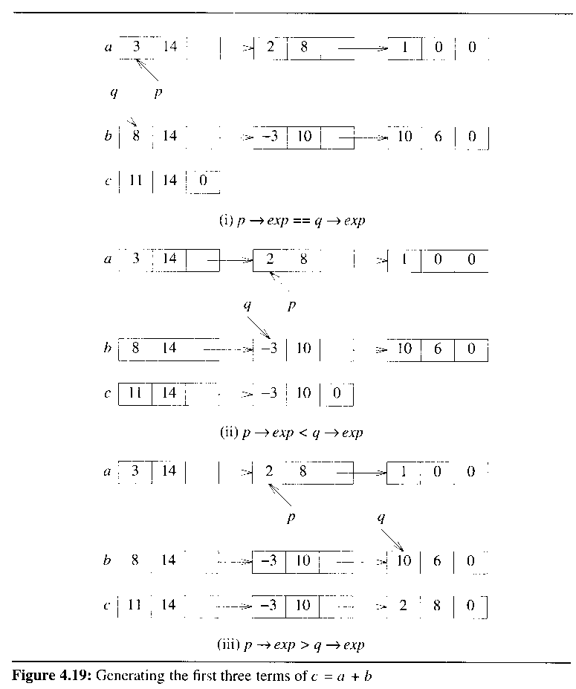
Figure 4.20

assume that a and b have m and n terms

the total number of terms : m + n

the computing time: O(m+n)

iterator object를 사용하는 방법을 공부할 것

Program 4.24:Adding two polynomials

4.7.3 Erasing polynomials

d(x) = a(x) * b(x) + c(x)

viod func( )

{

polynomial a, b, c, d, t;

cin >> a; // read and create polynomials

cin >> b;

cin >> c;

t = a * b

d = t + c;

cout << d;

}

after function func has been exited

need to return the memory occupied by a, b, c, t, d

delete only the polynomial class objects and the List<Term> objects by destructor

ListNode<Term> objects are not deleted

not possible to access ListNode objects

the memory ListNode objects occupy is lost
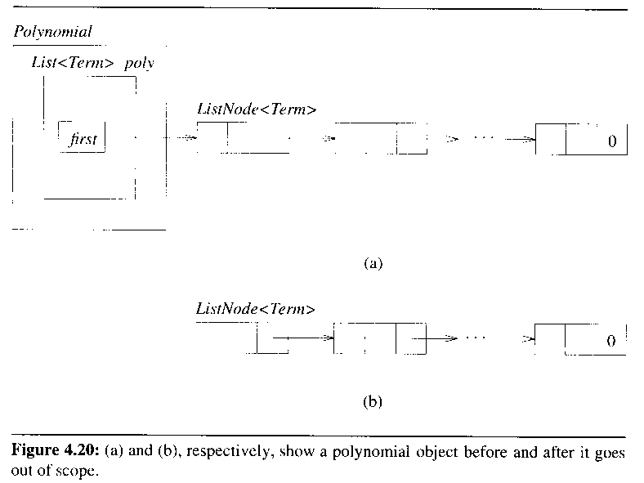

have to define a destructor to delete all objects that are conceptually part of a class

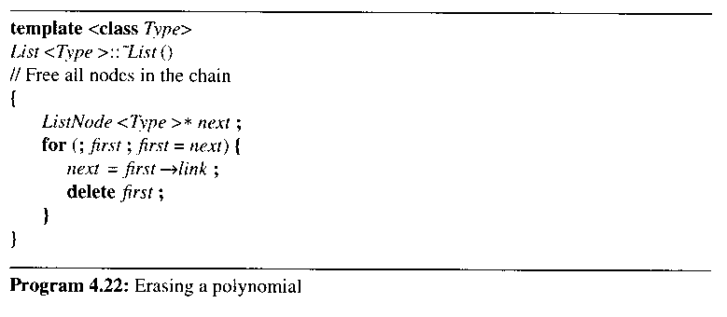

4.7.4 Circular list representation of polynomials

possible to free all the nodes in a list more efficiently by employing a circular list

an efficient erase algorithm for circular lists

maintain a chain of nodes(av list, available-space list) that have been "deleted"

if av list is empty, then need to use command new to create a new node

let av be a static class member of CircList<Type> of type ListNode<Type>

use the functions CircList::GetNode and CircList::RetNode instead of new and delete
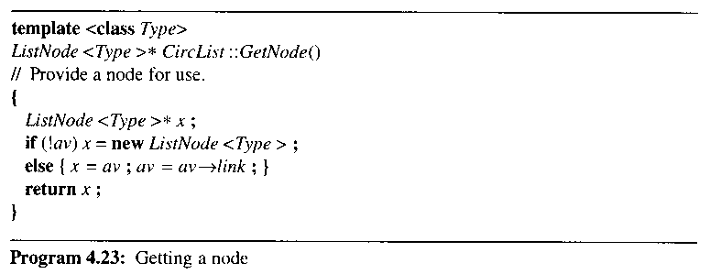

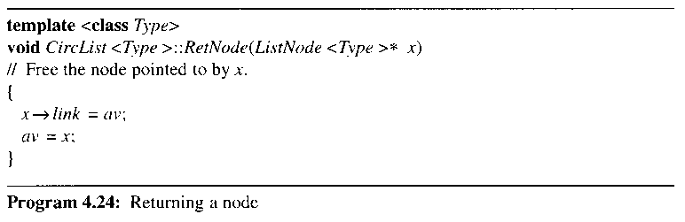

erase a circular list by function CircList<Type>::~CircList
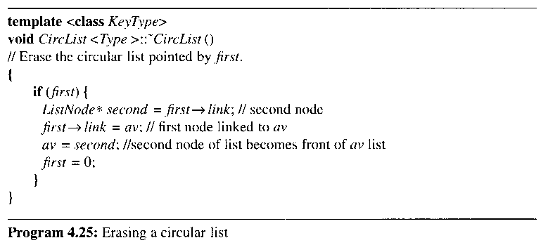
- the variable first points to the last node like Figure 4.15

have to handle the zero

introduce a head node into each polynomial as a special case during addition and deletion
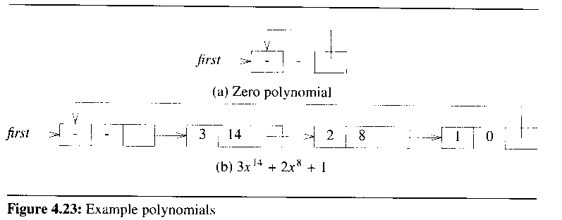

remove the test for first == 0 from ~CircList( )

the exp field of the head node is set to -1

no need for additional code to copy the remaining terms as in operator+( )

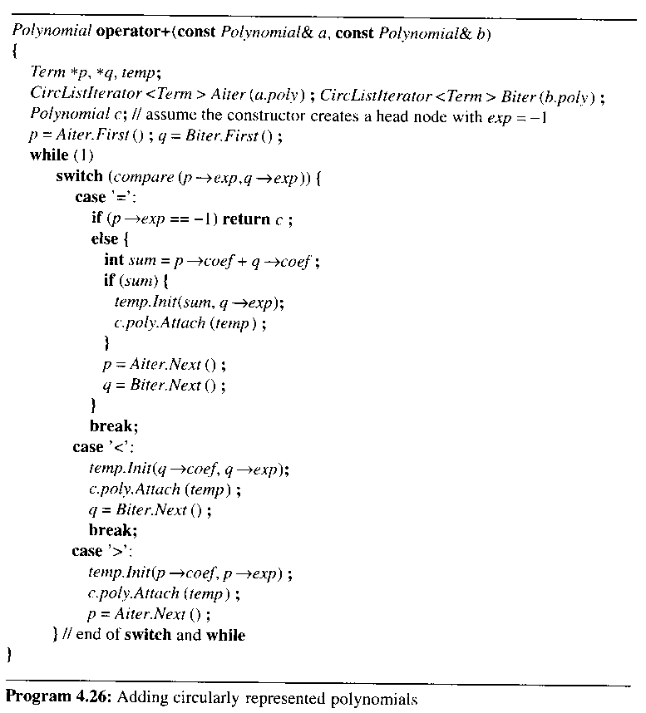

4.8 Equivalence classes

4.3.4 Reusing a Class절에서 언급한 내용

“there are some scenarios where one should not attempt to reuse a class”

the operations required by the application are complex and specialized

1) x = x : reflexive

2) x = y, y = x : symmetric

3) x = y, y = z, x = z : transitive

Def) a relation ≡ over a set S is an equivalence relation over S iff it is symmetric, reflexive, transitive over S

partition the set S into equivalence classes

the algorithm to determine equivalence classes

1) 1st phase

read and store the equivalence pairs (i, j)

2) 2nd phase

begin at 0 and find all pairs of the form (0, j)

by transitively, all pairs of the form (j, k) is in the same class as 0
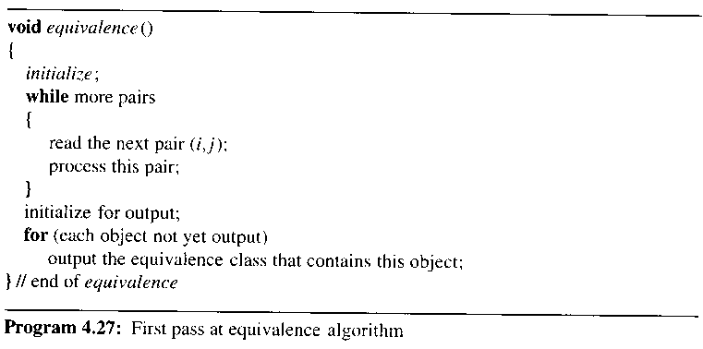

how to implement the data structures for holding pairs

1) using array pairs[n][n]

pairs[i][j] = TRUE iff i and j are paired

wasteful of space

require O(n**2) time, to initialize the array

2) consider a linked list to represent each row

still need random access to the ith row

seq[n] can be used as the head node of the n lists

need a mechanism that tells us whether or not object i is yet to be printed

out[n]
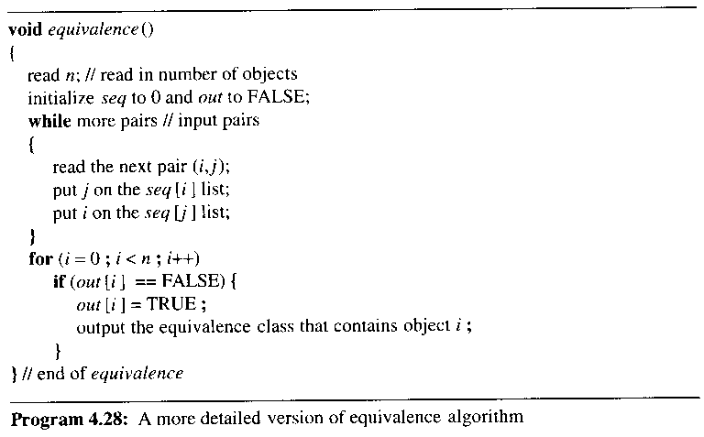

seq[i] points to a list of nodes that contains every number directly equivalent to i

create a stack of nodes, to process the remaining lists which, by transitivity, belong in the same class as i

accomplished by changing the link data members
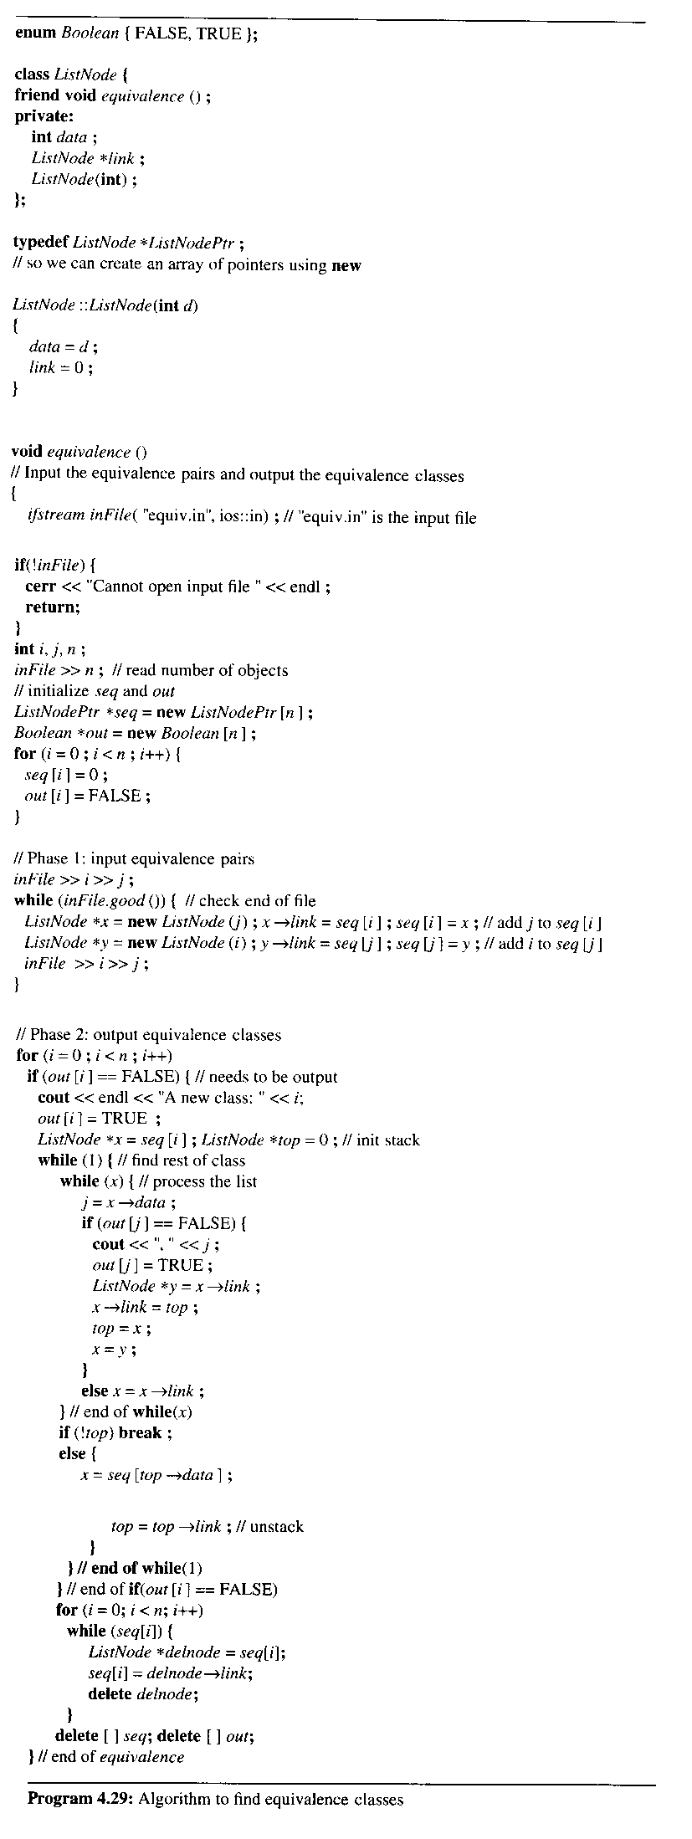
while(x) {//process the list
j = x->data;
if (out[j] == FALSE) {
cout<<”,”<<j;
out[j] = TRUE;
ListNode *y = x->link;
x->link = top;
top = x;
x = y;
}
else x = x->link;
} //end of while(x)
if (!top) break;
else {
x = seq[top->data];
top = top->link;//unstack
}

4.10 Doubly linked lists

difficulty with singly linked lists

difficult to find the node that precedes p

deletion of an arbitrary node requires knowing the preceding node

a doubly linked circular list
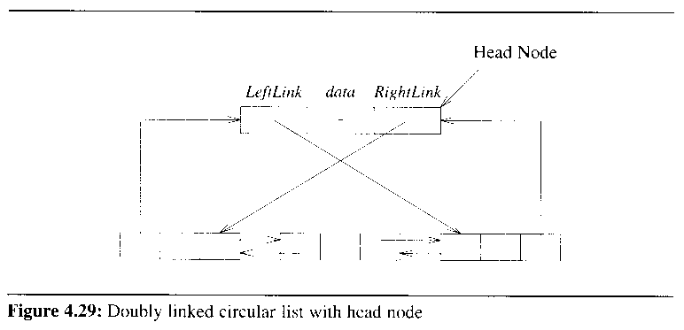

empty doubly linked list with head node

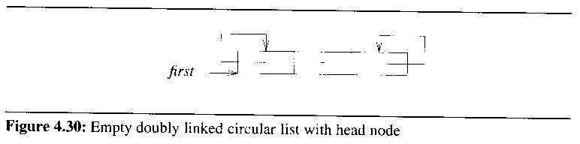

p == p→llink→rlink == p→rlink→llink

one can go back and forth with equal ease

the class definition of a doubly linked list
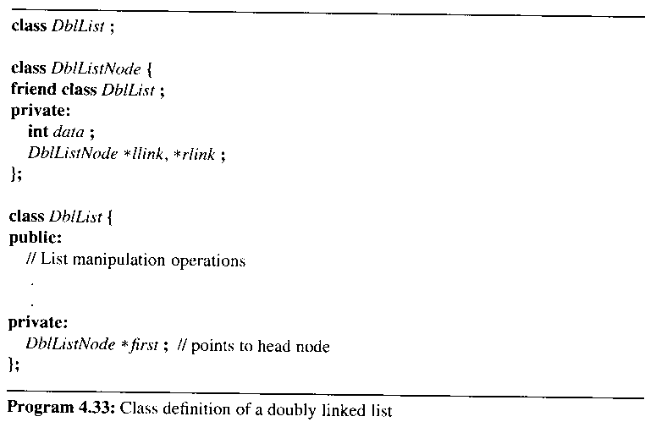

insertion into and deletion from a doubly linked circular list
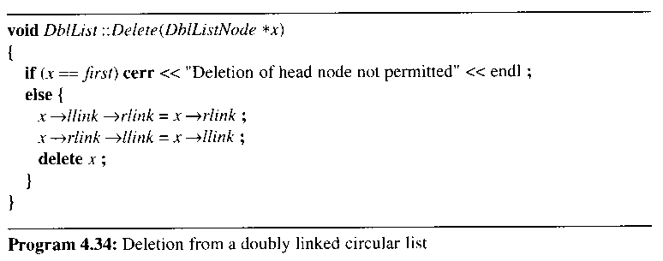
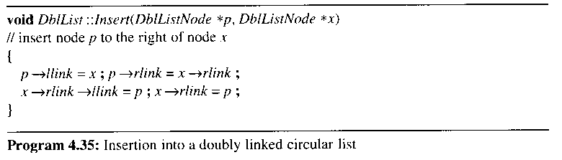

본 강의 자료의 그림 및 알고리즘 발췌
저자 : HOROWITZ
타이틀 : FUNDAMENTALS OF DATA STRUCTURES IN C++ 2nd Edition (2006)
공저 : SAHNI, MEHTA
출판사 : Silicon Press

