Chapter 6 GRAPHS

6.1 The graph abstract data type

6.1.1 Introduction

the konigsberg bridge problem

to determine whether, starting at one land area(node), it is possible to walk across all the bridges(arc) exactly once in returning to the starting land area
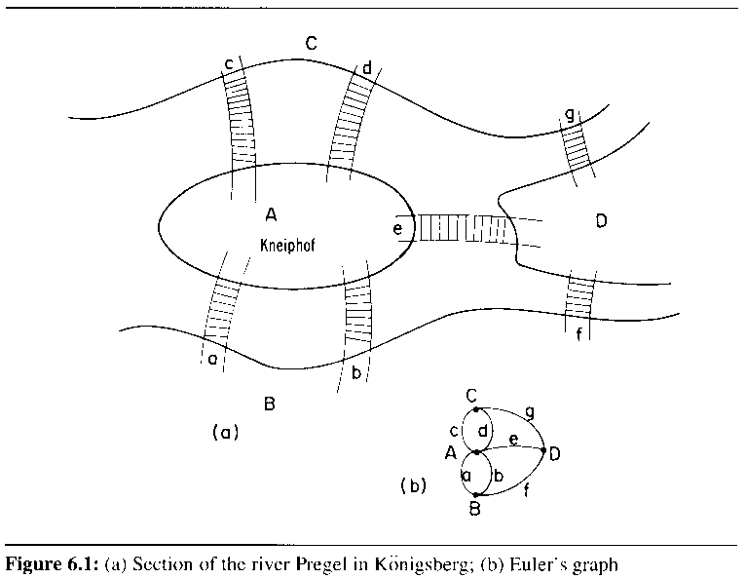

do not go across all bridges (edges) exactly once
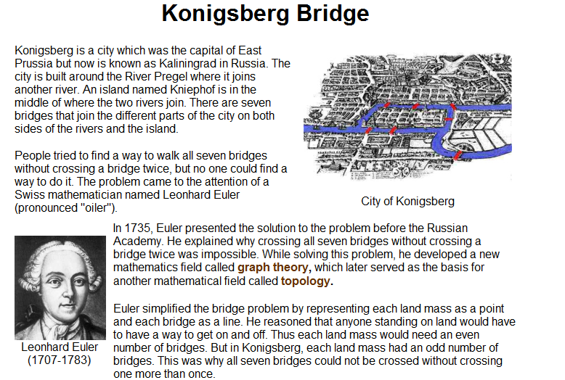

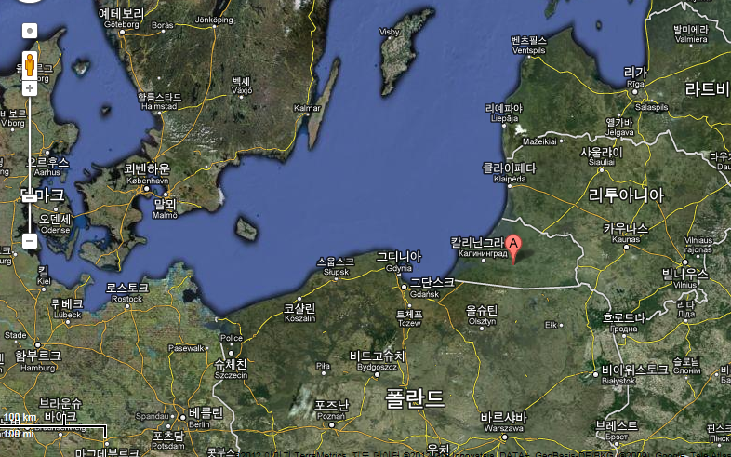

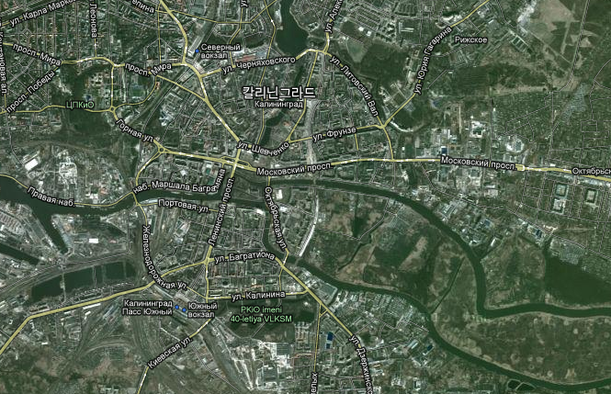

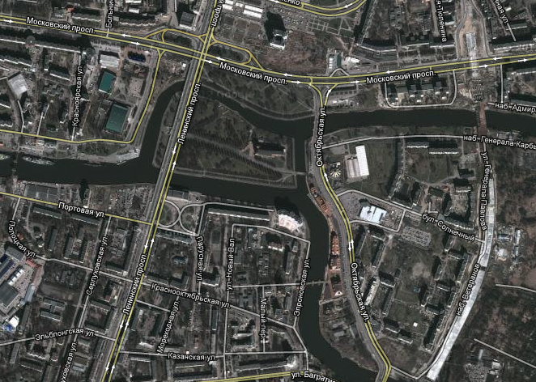

the degree of a vertex

# of edges incident to the vertex

Eulerian path

go through each edge exactly once and terminate at the start vertex iff the degree of each vertex is even

6.1.2 Definitions

V(G): the sets of vertices of graph G

E(G): the sets of edges of graph G

G = (V, E)

undirected graph

(u, v) and (v, u) represent the same edge

directed graph

<u, v> represents one edge

u: tail

v: the head of the edge
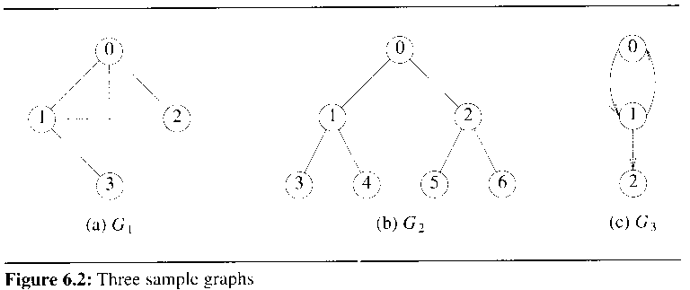

define the edges and vertices of a graph as sets

a graph may not have an edge from a vertex, v, back to itself

(v, v) are not legal

G consists of two sets, V and E

V is a finite, nonempty set of vertices

E is a set of pairs of vertices(distinct)

called self edges or self loops

a graph may not have multiple occurrences of the same edge, called multigraph
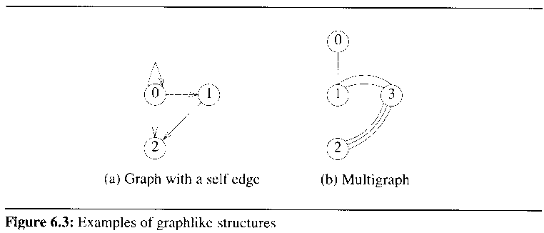

complete graph

a n-vertex, undirected graph with exactly n(n-1)/2 edges (the maximum number of edges in any n-vertex, undirected graph)

G1 of FIG 6.2(a)

if (u, v) is an edge in E(G)

1) u and v are adjacent

2) the edge (u,v) is incident on u and v

if <u, v> is a directed edge

1) u is adjacent to v

2) v is adjacent from u

3) the edge <u, v> is incident to u and v

a subgraph G' of G

V(G') <= V(G) and E(G') <= E(G)
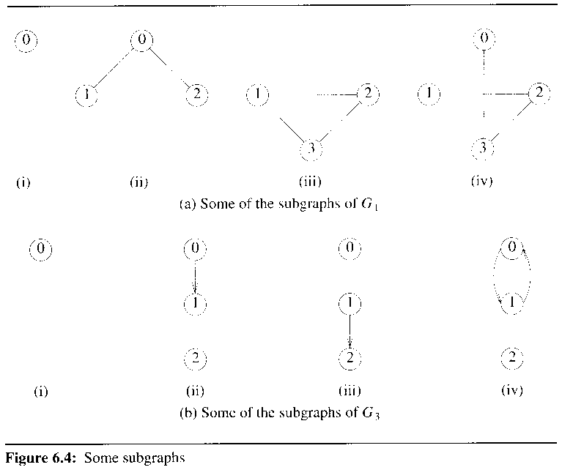

path from u to v

a sequence of u, i₁, i₂, ..., i_{k}, v

the length of a path = # of edges on a path

simple path

a path in which all vertices except possibly the first and last are distinct

cycle

a simple path in which the first and last vertices are the same

u and v are said to be connected iff there is a path in G from u to v

connected component, H, of an undirected graph is a maximal connected graph
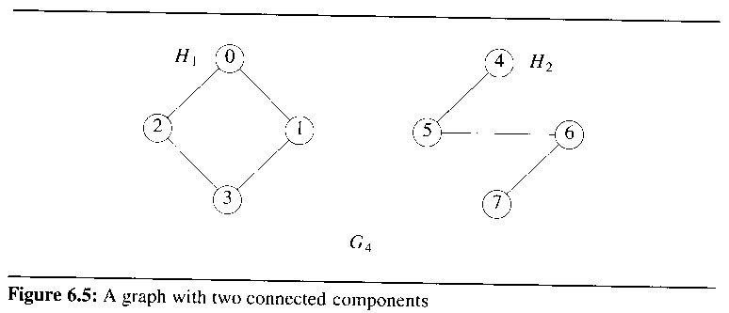

tree is a connected acyclic graph

a directed graph G is strongly connected iff for every pair of distinct vertices u and v, there is a directed path from u to v and also from v to u

FIG 6.2(c) G3: not strongly connected
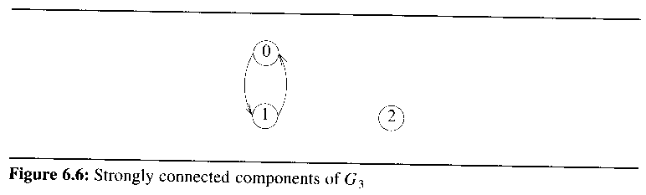

a strongly connected component

a maximal subgraph that is strongly connected

the degree of a vertex

# of edges incident to that vertex

if G is a directed fraph

1) in-degree of a vertex v = # of edges for which v is the head

2) out-degree of v = # of edges for which v is the tail
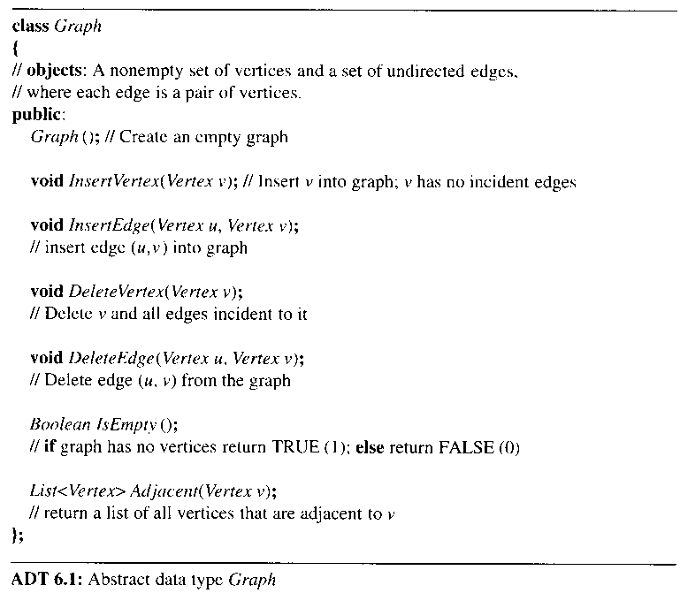

6.1.3 Graph representation
6.1.3.1 Adjacency Matrix

the adjacency matrix of G = (V, E)

A[i][j] = 1 iff the edge (i,j) is in E(G)

how many edges are there in G

O(n*n)
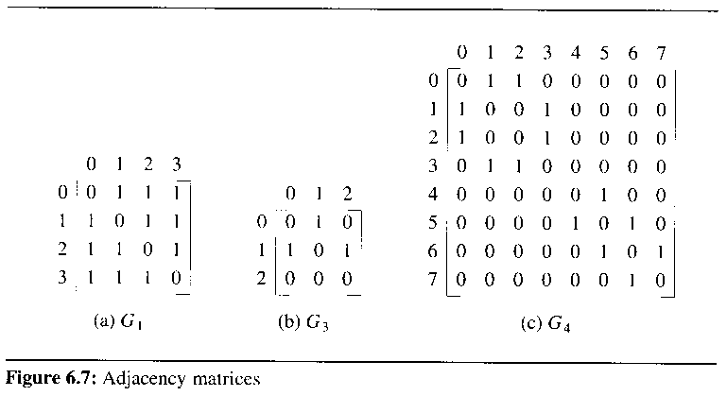
6.1.3.2 Adjacency Lists

one list for each vertex in G

the nodes in list i represent the vertices that are adjacent from vertex i
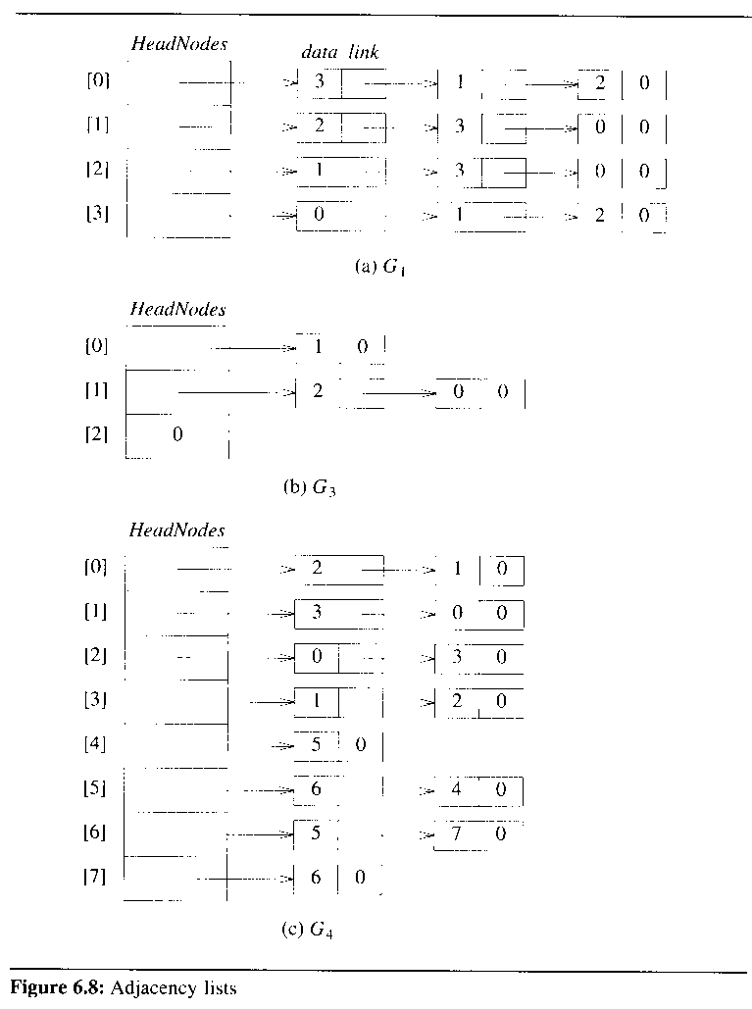

the adjacency list representation

class Graph

{

private:

List<int> *HeadNodes;

int n;

public:

Graph(const int vertices = 0): n(vertices)

{ HeadNodes = new List<int> [n];};

};

for G with n vertices and e edges, requires n head nodes and 2e list nodes

sequentially pack the nodes on the adjacency lists, eliminating the use of pointers

use an array node [n + 2e + 1]

node[i] gives the starting point of the list for vertex i

node[n] is set to n + 2e + 1
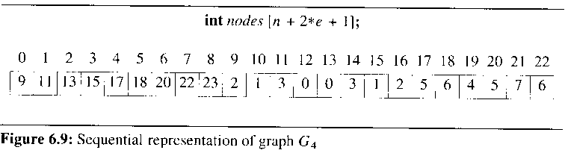

the vertices adjacent from vertex i are stored in node[i] …, node[i+1]-1

노드 0에 인접한 노드들:

node[0], …, node[0+1]-1

= 9, …, 11-1

find the number of edges of G, using adjacency list

O(n + e) time

for a digraph, # of list nodes is e

the out-degree of any vertex = # of nodes on its adjacency list

determining the in-degree of a vertex is complex

inverse adjacency lists
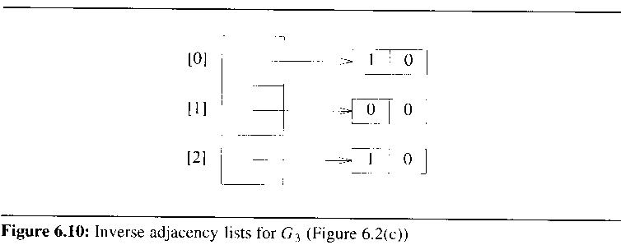

sparse matrix representation
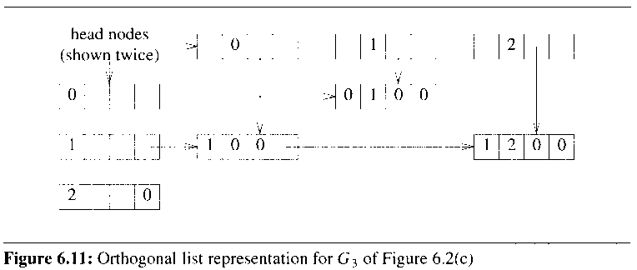

6.1.3.3 Adjacency Multilists

in the adjacency list representation of an undirected graph, each edge (u,v) is represented by two entries

need to check if all the edges is visited exactly once

the new node structure

for each edge, there will be exactly one node

m : indicate whether or not the edge has been examined
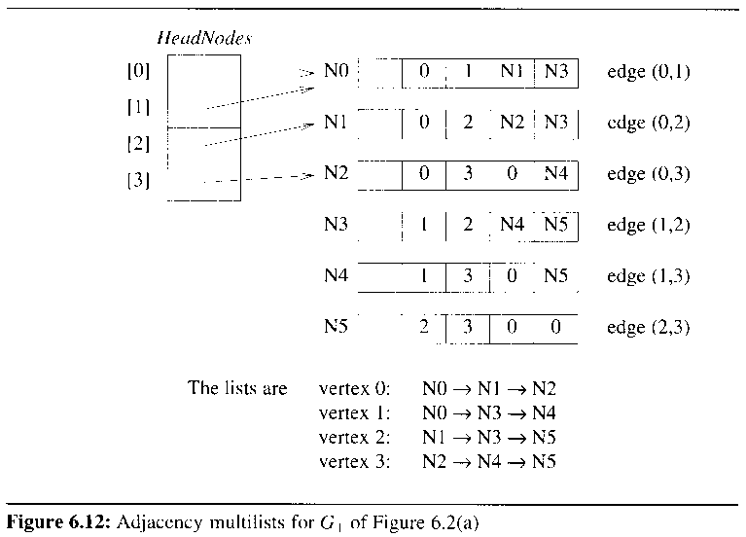

FIG 6.12 : adjacency multilists for G1

list node: 하나의 edge 표현

6.1.3.4 Weighted Edges

network

a graph with weighted edges

6.2 Elementary graph operations

for G = (V, E) and a vertex v in V(G), visit all vertices in G that are reachable from v

6.2.1 Depth-first search
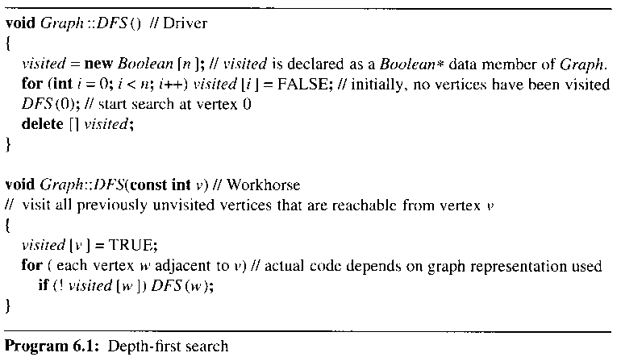

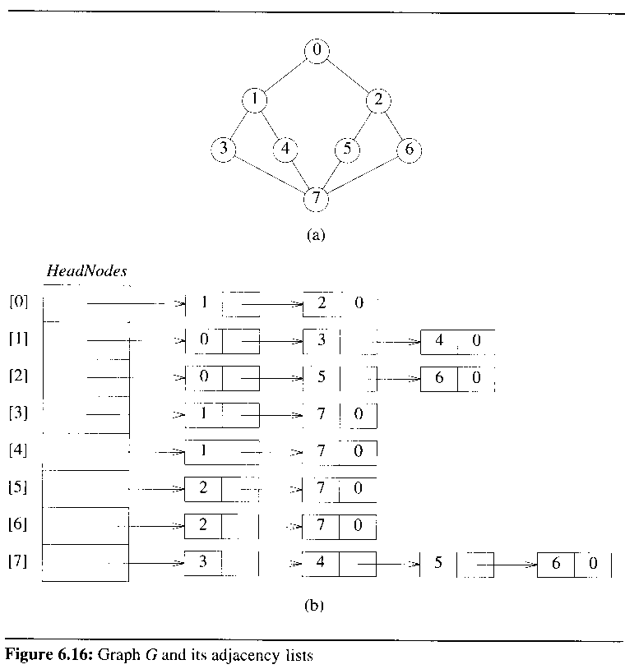

6.2.2 Breadth-first search
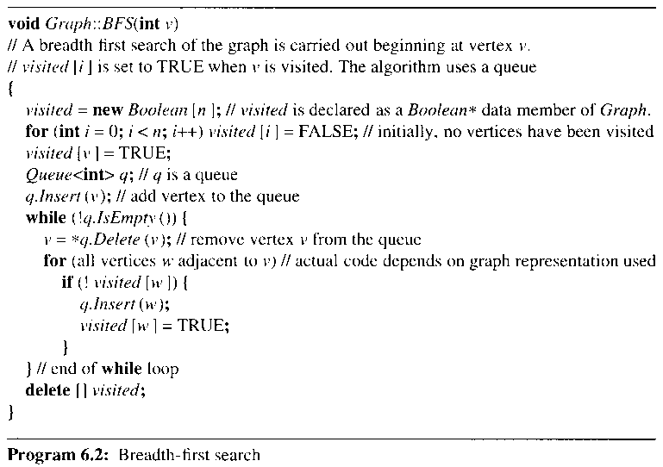

6.2.3 Connected components

obtain the connected components

make repeated calls to DFS(v) or BFS(v), where v has not yet been visited
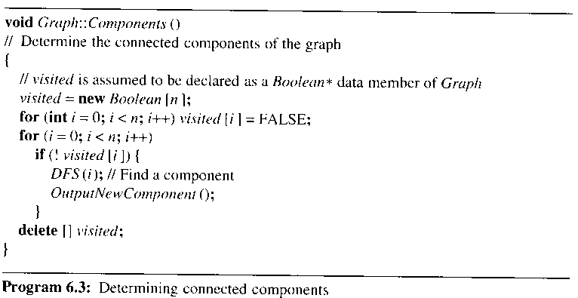

DFS(i); 하나의 connected component를 찾음

6.2.4 Spanning tree

DFS or BFS partitions the edges of G into two sets, T(tree edges) and N(nontree edges)

T may be determined by inserting the statement T = T + {(v,w)}

the edges in T form a tree that includes all the vertices of G

called a spanning tree
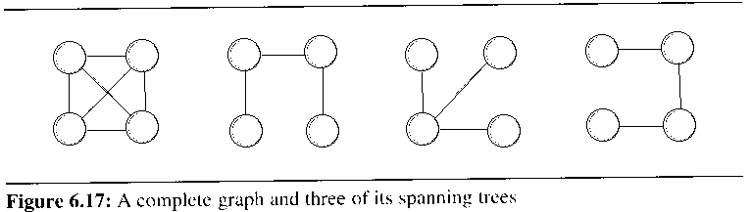

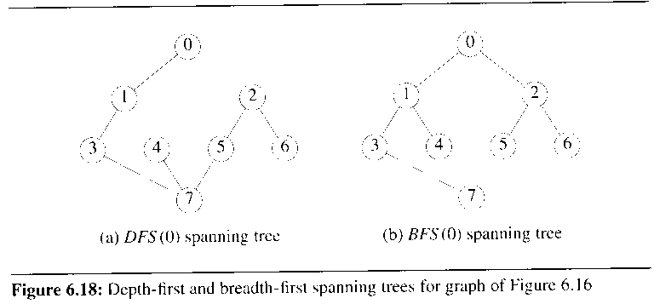

depth-first spanning tree : FIG 6.18(a)

breadth-first spanning tree: FIG 6.18(b)

a spanning tree

a minimal subgraph, G', of G such that V(G') = V(G), G' is connected

a minimal subgraph : a graph with the fewest number of edges

6.2.5 Biconnected components(skip)

assume that G is an undirected, connected graph

a vertex v of G is an articulation point iff the deletion of v results in at least two connected components

vertices 1,3,5,7 in FIG 6.19(a) are the articulation points

(v1, v2)의 경우에 v1은 no articulation point

a biconnected graph is a connected graph that has no articulation points

a biconnected component is a maximal biconnected subgraph H of G
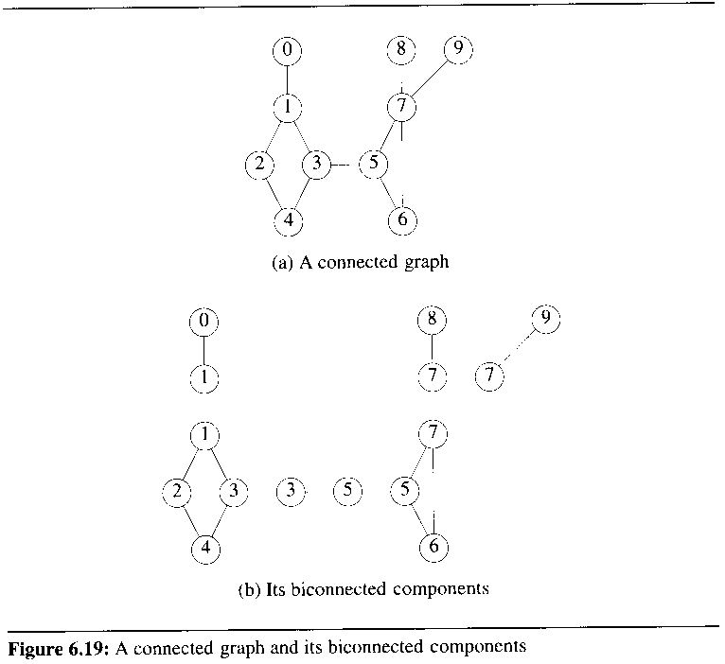

two biconnected components of the same graph can have at most one vertex in common

no edge can be two or more biconnected components

find the biconnected components by using depth-first spanning tree

a depth-first spanning tree with root 3
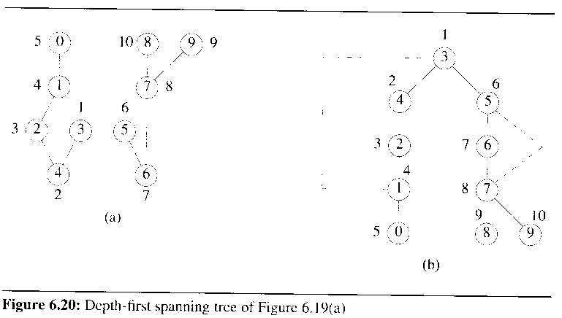

a nontree edge (u, v) is a back edge iff u(v) is an ancestor of v(u)

show the nontree edges of G by broken lines

a cross edge

a nontree edge that is not a back edge

no graph can have cross edges with respect to any of its depth-first spanning trees

the depth-first number, dfn, of the vertex

the numbers outside the vertices

the sequence in which the vertices are visited during DFS

dfn(0) = 5, dfn(9) = 10

dfn(u) < dfn(v) if u is an ancestor of v in the depth-first spanning tree

the root of the depth-first spanning tree is an articulation point iff it has at least two chilren

any other vertex u is an articulation point iff it has at least one child, w

not possible to reach an ancestor of u using descendants of w and a single back edge

low(w) : the lowest depth-first number that can be reached from w using a path of descendants followed by at most one back edge

low(w) = min{ dfn(w), min{low(x) | x is a child of w}, min {dfn(x) | (w,x) is a back edge}}
x
w
x
w
X is a child of w
(w,x) is a back edge

u is an articulation point, iff u is the root of the spanning tree and has two or more children or u is not the root and u has a child w such that low(w) >= dfn(u)
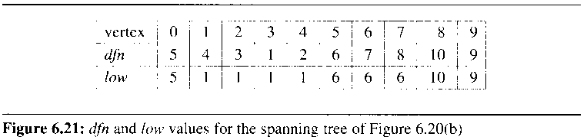

every student should be able to make FIG 6.21!!!
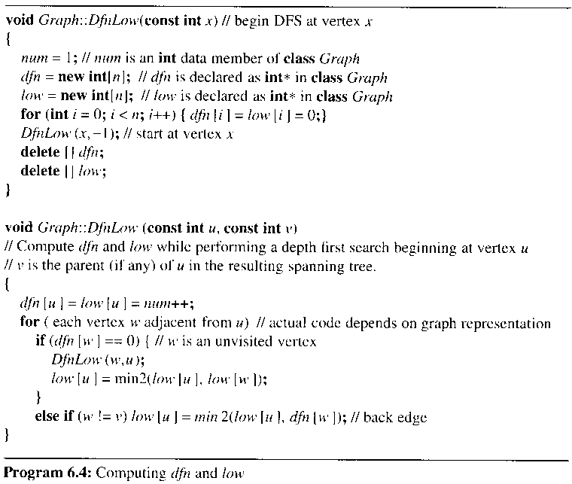

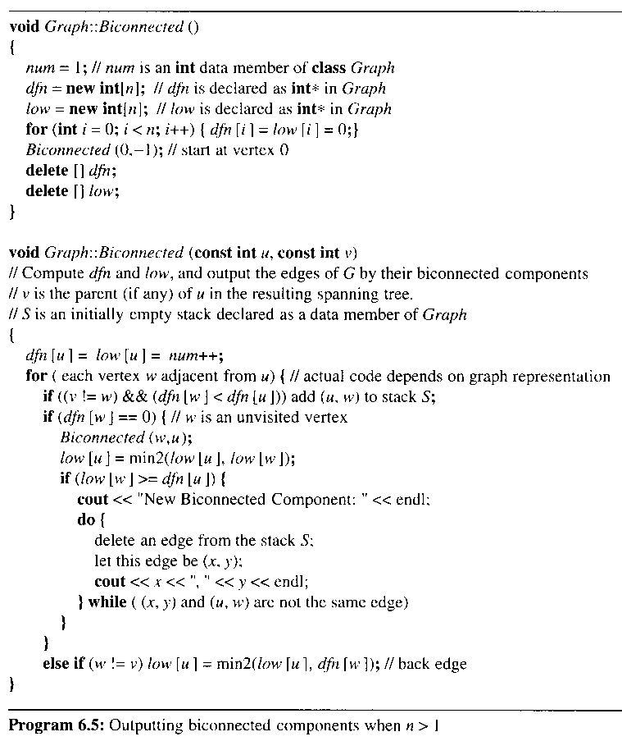

6.3.1 Kruskal's Algorithm

build a minimum-cost spanning tree T by adding edges to T one at a time

select the edges for inclusion in T in nondecreasing order of their cost

an edge is added to T if not a cycle

select n-1 edges for inclusion in T for G with n vertices
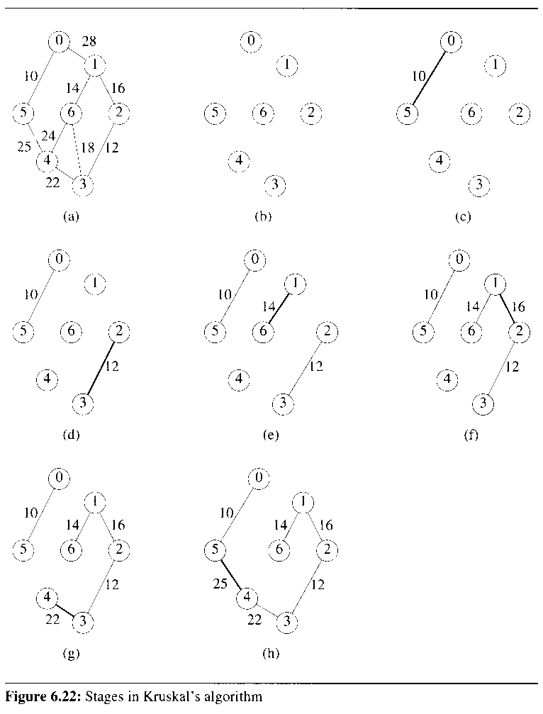

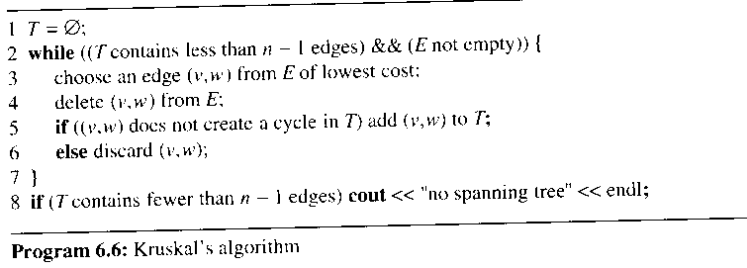

choose an edge (v,w) from E of lowest cost

sort these edges into nondecreasing order in time O(e log e)

in a min heap, determine the next edge in O(log e) time

if ((v,w) does not create a cycle in T) add(v, w) to T;

place all vertices in the same connected component of T into a set

two vertices v and w are connected in T iff they are in the same set

the use of trees in the representation of sets

v,w가 이미 the same set에 있으면 cycle 형성

6.3.2 Prim's Algorithm

the set of selected edges forms a tree

begin with a tree T that contains a single vertex

add a least-cost edge (u, v) to T such that T + {(u, v)} is also a tree

TV = {0}

(0,5), (0,1) 중에서 cost가 min인 edge를 선택

TV = {0,5}이 되며 후보 edge는 (0,1), (5,4) 이 됨

TV에 있는 노드 집합에 연결된 edge 중에서 cost가 min인 것을 선택함
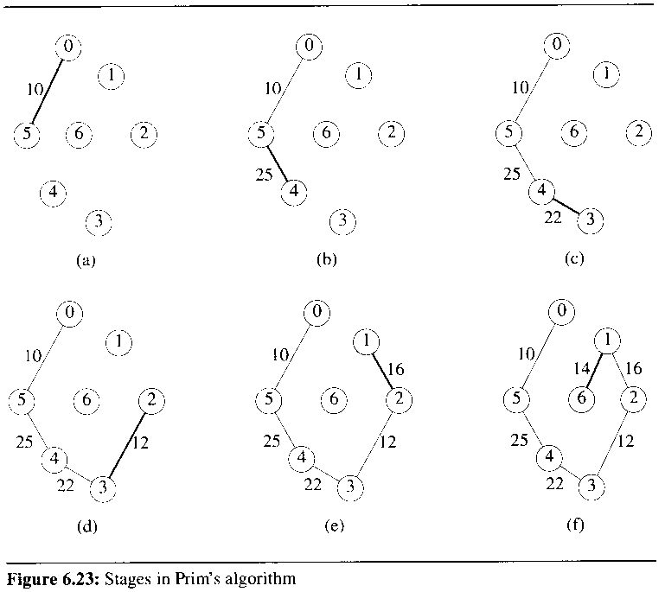

the set of selected edges forms a tree

the set of selected edges in Kruskal’s algorithm forms a forest at all times

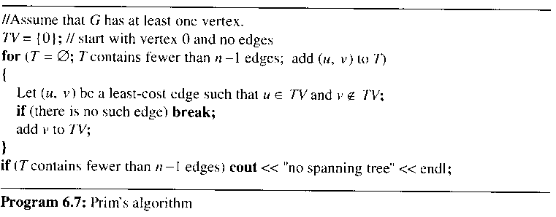

6.3.3 Sollin's Algorithm

select several edges at each stage

the selected edges form a spanning forest

select one edge for each tree in a spanning forest, with all n graph vertices

we select one edge for each tree in this forest

the selected edge is a minimum-cost edge that has exactly one vertex in the tree
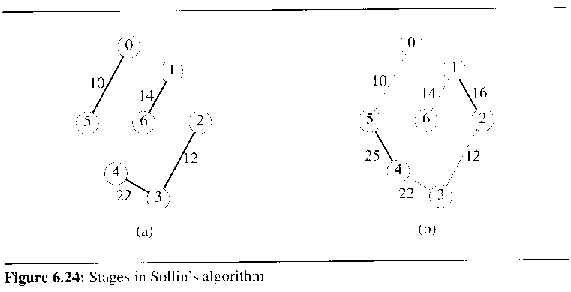

stage 1: FIG 6.24(a)

stage 2: FIG 6.24(b)

본 강의 자료의 그림 및 알고리즘 발췌
저자 : HOROWITZ
타이틀 : FUNDAMENTALS OF DATA STRUCTURES IN C++ 2nd Edition (2006)
공저 : SAHNI, MEHTA
출판사 : Silicon Press

